Media Release
Tuesday August 20, 2019

COMPETITION AND CAMARADERIE ON SHOW AS CORPORATE SPORTS’ SUMMER TOURNAMENT BUILDS TO THRILLING CLIMAX
The action is heating up at Dubai Sports World at the World Trade Centre as Corporate Sports’ Summer Tournament heads towards the pointy end.
With over 700 participants representing 18 of the UAE’s top companies, from the private and public sector, competition has been fierce but friendly in the six sports on show – football, basketball, table tennis, volleyball, cricket and badminton.

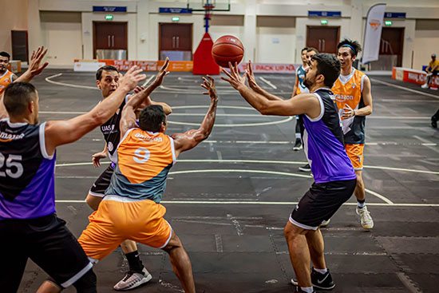

With a total of 221 matches to be played across all competitions the finals are set down for August 31 with teams desperate to clinch a semi-final berth in the remaining rounds.
One of the players taking part in the latest round of matches was the CEO and founder of Corporate Sports himself, Mohammed Husary, who showed a clean pair of heels – as well as some impressive three-point accuracy - as the UAS men’s basketball team edged out Dubai Health Authority (DHA).
In a thrilling contest Husary made a big impact coming off the bench in the final term to see UAS squeak home, 75-69.

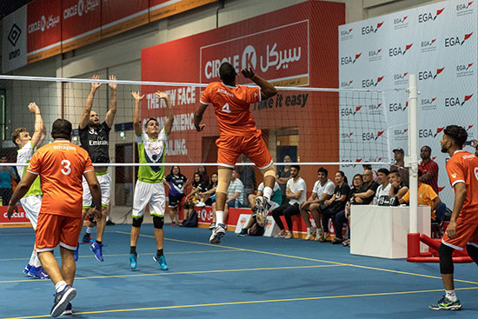
“The excitement here is palpable”, said an elated Husary on court after the match. “The game was very close – six points difference – and in basketball that’s very tight as you know.”
“The atmosphere here is electric, the cheering from the audience was really motivating. We had a great time.”
Watching on from the side lines was Abdullah Saeed Al Falasi, the Head of DHA’s Sports Committee, who also commented on the big match atmosphere at the tournament.
“It is amazing, especially for the team morale,” he exclaimed. “It is so important that employees do team activities like this every quarter, at least.”
Al Falasi urged more companies to get involved in future Corporate Sports’ events: “All corporates, regardless of size, should be getting involved in these types of sporting events,” he added.
“For most of the day, employees sit at their desks without much exercise. Companies should be actively creating opportunities for their staff to work as a team in a sporting environment, not only for team-building, but for improving each individual’s fitness and overall health.”
The Summer Tournament is one of a trio of Corporate Sports’ contests, the other two being the Ramadan Tournament and the main event, the Corporate Sports Championship, last year won by telecommunication leaders du, held annually in February.
“We’ve had a great response to the Summer Tournament,” said Corporate Sport’s Corporate Wellness Director, Simon Seward.
“In total there’s 18 different companies from a variety of industries all-round the UAE, which is amazing.
“We have guys coming in from Ajman on the bus every single Monday and Wednesday, guys coming all the way from Abu Dhabi so the response has been great and we hope it inspires the individuals to stay active during summer, which is exactly why we are doing it.”
UAS’s victory saw them sneak into the basketball top four but they are still three games back from the undefeated Amazon 1, while DHA are now in sixth place and must beat Amazon 2 this Wednesday night to keep their playoff hopes alive.
DHA however are shaping up well in the football tournament, as they aim for the crown of the Summer Tournament’s overall champions, but they have their work cut out against a classy Dubai Police team who have racked up an incredible 31 goals in their first three games while conceding just two.
Dubai Immigration, Dubai Customs and Zerofat have also impressed early doors on the football pitch and look set to run deep into the competition.
One of the most hotly contested tournaments, as usual, is cricket where a fired-up Naffco 1 team lead with five wins from five starts although they may face some challenges from ENOC, Amazon and their work colleagues Naffco 2 in the run to the semis.
DHA and Emirates are battling it out at the top of the mixed volleyball ladder while in men’s Table Tennis Amazon’s Kantesh Patil, Retail Logistics’ Sufiyan Jetham, PWC’s Saugaat Allabadi and Joey from Naffco are the early pacesetters. The female Table Tennis hits the tables this Wednesday.
In men’s Badminton ENOC dominate with three of the top four players hailing from the oil giants: Naif Ubaid, Mani Kandan Anitha and Deepak Chandran. The one player breaking up the ENOC monopoly is Amazon’s Varun Sharma.
ENOC again lead the way in the women’s tournament with Muna Alsahlawi winning three from three but she looks like she’ll be pushed all the way by DHA’s Jeanielie Cabulong who also boasted a perfect record after three rounds.
The badminton doubles are headed up by Naffco’s Ruth & Jeffin and Jomin & Abhi and Amazon’s Azim & Tariq and Anuj & Sakshi who all have two wins from their opening two starts.
The action continues every Monday and Wednesday from 7pm-10pm at the World Trade Centre, for the next fortnight before what is set to be at thrilling day of finals on Saturday August 31, from 2pm.
And the good news if you want to catch the best in corporate sporting action, entry is free for all spectators, just register quickly at the door before entering.
For the latest scores, updated tables and up-coming fixtures go to https://corporatesports.ae/summer-tournament-2019-event-page/
For more information contact Corporate Sports’ Marketing Manager Lauren Haworth on lauren@corporatesports.ae or +971 54 792 9998
Rights free images attached.

