VISITORS from japan to dubai surpass 100,000 MARK for
the first time

- Emirate saw 15.3 percent year-on-year increase in overnight visitors from Japan during 2018
- Record-breaking growth reflects Dubai’s continued commitment to Japan’s dynamic travel market

Dubai, UAE, 3 April 2019: Dubai’s Department of Tourism & Commerce Marketing (Dubai Tourism) reported record growth in overnight visitors from Japan, crossing the 100,000 mark for the first time at the end of 2018. Reflecting a 15.3 percent year-on-year increase, the emirate welcomed 104,843 overnight visitors, with the robust growth underscoring efforts to further showcase the breadth of the city’s ever-expanding tourism proposition, cementing Dubai’s ongoing commitment to the Japanese market.

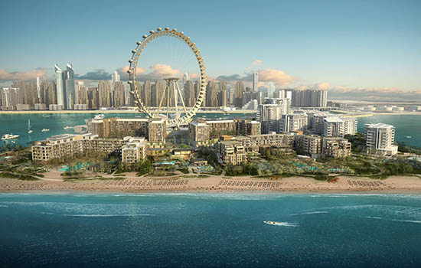

Adopting a custom market specific approach, Dubai Tourism continued to expand its reach across Japan targeting segmented demographics through strategic activations, always-on marketing campaigns and ongoing trade and business partnerships with key industry players. In order to drive awareness and consideration around Dubai as a holiday destination among Japan’s target market, the department identified women and senior citizens as key drivers in the travel and tourism space. Furthermore, building on the city’s commitment to ensure ease of accessibility, Japanese visitors benefit from daily flights from Tokyo Narita, Tokyo Haneda and Kansai International Airport in Osaka.

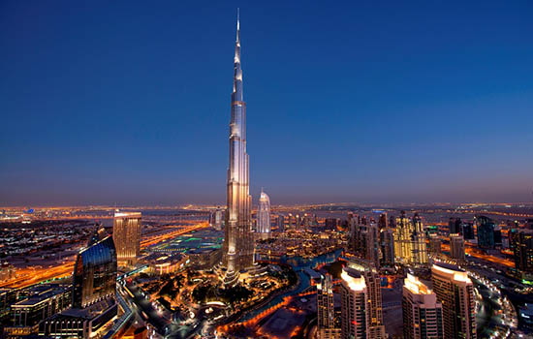

Issam Kazim, CEO of Dubai’s Corporation of Tourism & Commerce Marketing (DCTCM) said: “2018 saw sustained growth from the Japanese market as we welcomed more than 100,000 overnight visitors a year for the very first time. This milestone is testament to the market specific approach we’ve taken and the appeal of Dubai’s variety of attractions and experiences. With the market enthusiastic to learn more about the city, we will continue to work to enhance our holistic marketing efforts and strengthen our ongoing strategic partnerships with key industry leaders across multiple touch points, elevating the city’s position as the destination of choice for Japanese travellers.”

Dubai continues to be a key trending destination amongst young Japanese females, with the emirate witnessing an increase of 21 percent to 7.4 million mentions on social media from 2016 to 2018. Building on this growing interest, Dubai Tourism led a campaign to showcase the city as a safe and exciting destination specifically targeting young female travellers. The campaign leveraged user videos and image posts, as well as inviting users to participate in ongoing competitions throughout the year to showcase Dubai’s attractions to a broader audience. This campaign achieved 91.6 million impressions across a three month period, driving deeper engagement and encouraging wider conversations around Dubai.

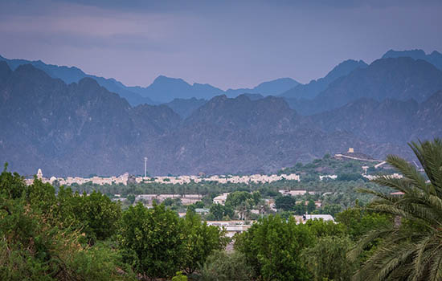

Working to deliver an enhanced travel experience for Japanese visitors to the emirate, Dubai Tourism has partnered with H.I.S. CO., LTD, a market leading travel agency in Japan to provide easy access to Dubai’s travel products and information though sales and retail promotions across major Japanese cities. Furthermore the department conducted a number of highly targeted marketing activations to highlight the city’s varied offerings to diverse audiences across Japan, including key broadcast projects that explored the city’s innovation in culture, sustainability and technology, as well as ongoing familiarisation trips and media events to highlight the city’s distinctive elements.

Working in conjunction with the Department’s comprehensive digital presence across multiple platforms in Japan, the city will continue to engage its target demographic with tailored experiences as well as showcasing the destination as a dynamic place to visit for a range of audiences. This includes leveraging locally relevant content creators from Japan to provide an avenue for authentic storytelling, presenting unique perspectives of Dubai and bringing the city to life through a highly personalised and engaging narrative.

– Ends –

About Dubai’s Department of Tourism and Commerce Marketing (Dubai Tourism)
With the ultimate vision of positioning Dubai as the world’s leading tourism destination and commercial hub, Dubai Tourism’s mission is to increase the awareness of Dubai among global audiences and to attract tourists and inward investment into the emirate. Dubai Tourism is the principal authority for the planning, supervision, development and marketing of Dubai’s tourism sector. It markets and promotes the Emirate’s commerce sector, and is responsible for the licensing and classification of all tourism services, including hotels, tour operators and travel agents. Brands and departments within the Dubai Tourism portfolio include Dubai Business Events, Dubai Calendar, and Dubai Festivals and Retail Establishment.

For further information, please contact:
Dubai Tourism
mediarelations@dubaitourism.ae
[+971] 600 55 5559
[+971] 4 201 7631

