DUBAI TOURISM PROMOTES ITS SUSTAINABILITY INITIATIVE WITH SUPPORT OF MINISTRY OF CLIMATE CHANGE AND ENVIRONMENT

- Sustainability Board Game introduced to companies outside hospitality sector
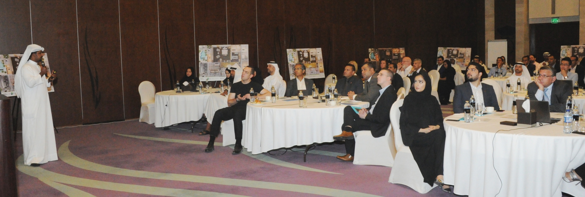
- Over 300 industry professionals from 75 hotels get to experience innovative educational game designed to encourage sustainable tourism

Dubai, United Arab Emirates, 29 August 2017: Dubai’s Department of Tourism and Commerce Marketing (Dubai Tourism) is taking its Hospitality Sustainability Board Game to a wider segment within the private sector, as part of efforts to encourage companies outside the hospitality sector to play a role in promoting sustainable tourism in Dubai.
An innovative educational tool, the Board Game is a key component of the Dubai Sustainable Tourism (DST) initiative launched by Dubai Tourism to position Dubai as the world’s leading sustainable tourism destination by helping hotels in the emirate adopt more eco friendly practices and efficiently manage their resources.
More than 300 industry professionals from 75 hotels have played the Board Game so far during events and roadshows organised by Dubai Tourism. However, with the aim of encouraging other companies to contribute towards the success of DST, Dubai Tourism organised another Board Game session recently in collaboration with the Ministry of Climate Change and Environment at Sofitel Dubai The Palm Resort & Spa.
The event was attended by senior officials of the Tourism Development and Investments department at Dubai Tourism including Executive Director, Yousuf Lootah and Senior Project Manager, Solaiman Al Rifai, as well as Mr. Hussain Hassan Mohamed Khansaheb, Director, International Cooperation Department, Ministry of Climate Change and Environment and Mr. Tanzeed Alam, Climate and Energy Director, EWS-WWF.
Ahmad Khalifa Al Falasi, CEO, Corporate Services and Investment, Dubai Tourism, said: ”We are delighted at the response we have received for the Hospitality Sustainability Board

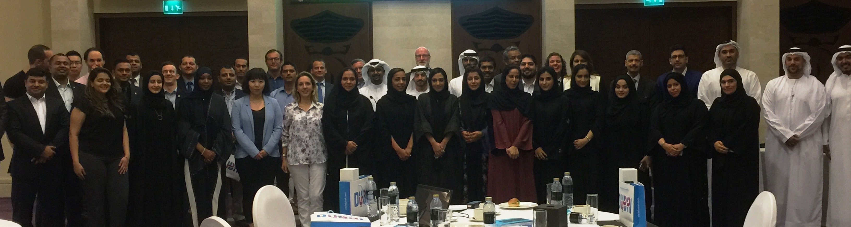
Game, a unique educational tool that was developed to create awareness of ways of reducing the carbon footprint in line with our Dubai Sustainable Tourism initiative. At this stage of our sustainability drive, we wish to highlight two significant developments – the involvement of the Ministry of Climate Change and Environment and the participation of companies outside the hospitality sector in the latest Board Game activity. The support extended by the Ministry of Climate Change and Environment and the enthusiasm shown by the new companies from the private sector is a clear demonstration of the fact that any initiative aimed at reducing energy and water consumption levels is not limited to improving the conservation methods in one industry but it is an obligation for all of us, in both government and private sectors to work together in achieving a cleaner, greener environment for Dubai.”
In his presentation at the event, Mr. Al Rifai, Senior Project Manager, Tourism Development and Investments at Dubai Tourism, gave an overview of DST, the mechanics of playing the Board Game and also highlighted the ways in which the private sector could play an even more active role in supporting DST.
The workshop was attended by hotel industry professionals including those who had participated in the previous two Board Game activities, to help the new players obtain a better understanding of how their establishments could benefit through sustainable practices.
The participants in the latest Board Game activity represented entities and companies in diverse sectors including hospitality, travel, environment, real estate and property, to name a few.
Hussain Hassan Mohamed Khansaheb, Director, International Cooperation Department, Ministry of Climate Change and Environment, said: “The UAE aims to transform its national economy into a low-carbon green economy based on its development of knowledge and innovation. Carbon capture and storage technology adopted by the UAE is considered one of the most promising and important technologies in the field of carbon emission mitigation in industrial projects.”
“MOCCAE encourages innovative and technological initiatives in the environment and climate change sector that are in line with the global direction, urging private companies to

adopt corporate social responsibility programs that aim at reducing carbon emissions,” he added.
The Board Game was developed jointly with Emirates Wildlife Society-WWF, one of four key partners of DST. The other three leading sustainability entities that are supporting DST are Etihad ESCO, Dubai Carbon and Emirates Environmental Group. The Board Game was designed to raise awareness of sustainability in a fun and interactive way, allowing

participating teams to measure and reduce the levels of electricity and water consumption in their establishments, and in the process reduce costs.
- ends -
About Dubai’s Department of Tourism and Commerce Marketing (Dubai Tourism)
With the ultimate vision of positioning Dubai as the world’s leading tourism destination and commercial hub, Dubai Tourism’s mission is to increase the awareness of Dubai among global audiences and to attract tourists and inward investment into the emirate. Dubai Tourism is the principal authority for the planning, supervision, development and marketing of Dubai’s tourism sector. It markets and promotes the Emirate’s commerce sector, and is responsible for the licensing and classification of all tourism services including hotels, tour operators and travel agents. Brands and departments within the Dubai Tourism portfolio include Dubai Business Events, Dubai Calendar and Dubai Festivals and Retail Establishment.

FOR FURTHER INFORMATION, PLEASE CONTACT:
Dubai Tourism
mediarelations@dubaitourism.ae
+971] 600 55 5559
+971] 4 201 7631

