PRESS RELEASE

Dubai Tourism launches major international startup competition in collaboration with GITEX Future Stars
- Top 30 shortlisted companies to be awarded exhibition space at GITEX Technology Week (8-12 October 2017)
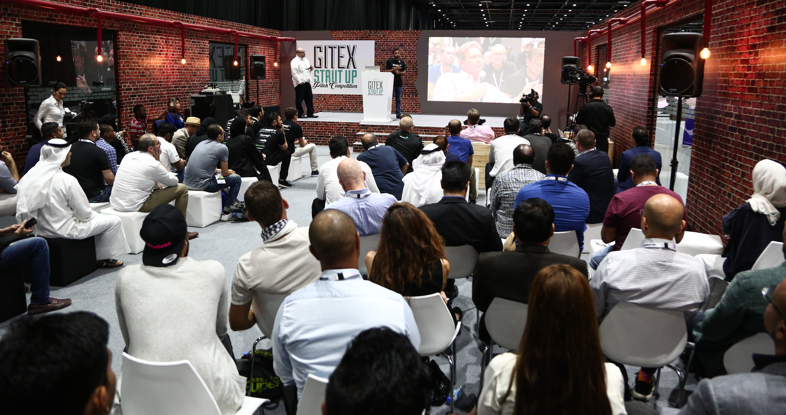
- Total prize value of US$ 100,000 to be awarded as capital to top three winners of the Hospitality and the Visitor Experience subcategories

Dubai, United Arab Emirates, 21 August 2017: Dubai’s Department of Tourism and Commerce Marketing (Dubai Tourism) has announced a strategic collaboration with GITEX Future Stars to launch the first-ever Dubai Tourism Startup Competition - Futurism, inviting bright minds and innovators from around the world to submit ideas and business plans that will further revolutionise the city’s travel and tourism sectors.

The competition is in line with the Dubai 10X initiative launched under the leadership of His Highness Sheikh Mohammed bin Rashid Al Maktoum, Vice-President and Prime Minister of the UAE and Ruler of Dubai, which is guiding the emirate’s journey towards becoming a global hub for innovation in the next ten years. It is also an effort towards discovering innovative solutions and facilitating further growth of the startup ecosystem, in alignment with Dubai’s Tourism Vision 2020, to attract 20 million visitors per year by 2020.

Speaking about the Dubai Tourism Futurism Competition, Yousuf Lootah, Executive Director - Tourism Development & Investments, Dubai Tourism, said: “Dubai has grown to become the business capital of the region – and, through the launch of the first-ever Dubai Tourism Futurism Competition, we aim to continue to encourage pioneering thinking, and offer a platform for startups to succeed. As we progress towards the future, startups play a crucial role not only in the growth of the economy, but also in discovering solutions to meet evolving needs and tackle industry gaps. We are proud to collaborate with GITEX Future Stars to drive entrepreneurship forward, and are committed to building an environment that will help nurture innovative ideas and facilitate success.”

The Futurism competition features two key pillar categories – hospitality and visitor experience – for which individuals and startups can submit innovative ideas and business plans. Each submission will be judged by panel of experts, and a shortlist of the top 30 submissions will be awarded exhibition space at this year’s edition of GITEX Technology Week, scheduled to take place in Dubai from 8-12 October 2017, offering a platform for the shortlists to showcase their innovative solutions to attending conglomerates, investors and venture capitalists. Ultimately, three winners will be selected in each category who will receive access to Dubai Tourism experts, as well as industry leaders to transform their vision to reality. A total prize value of US$ 100,000 has also been allocated to be distributed to the six winners as initial startup capital.
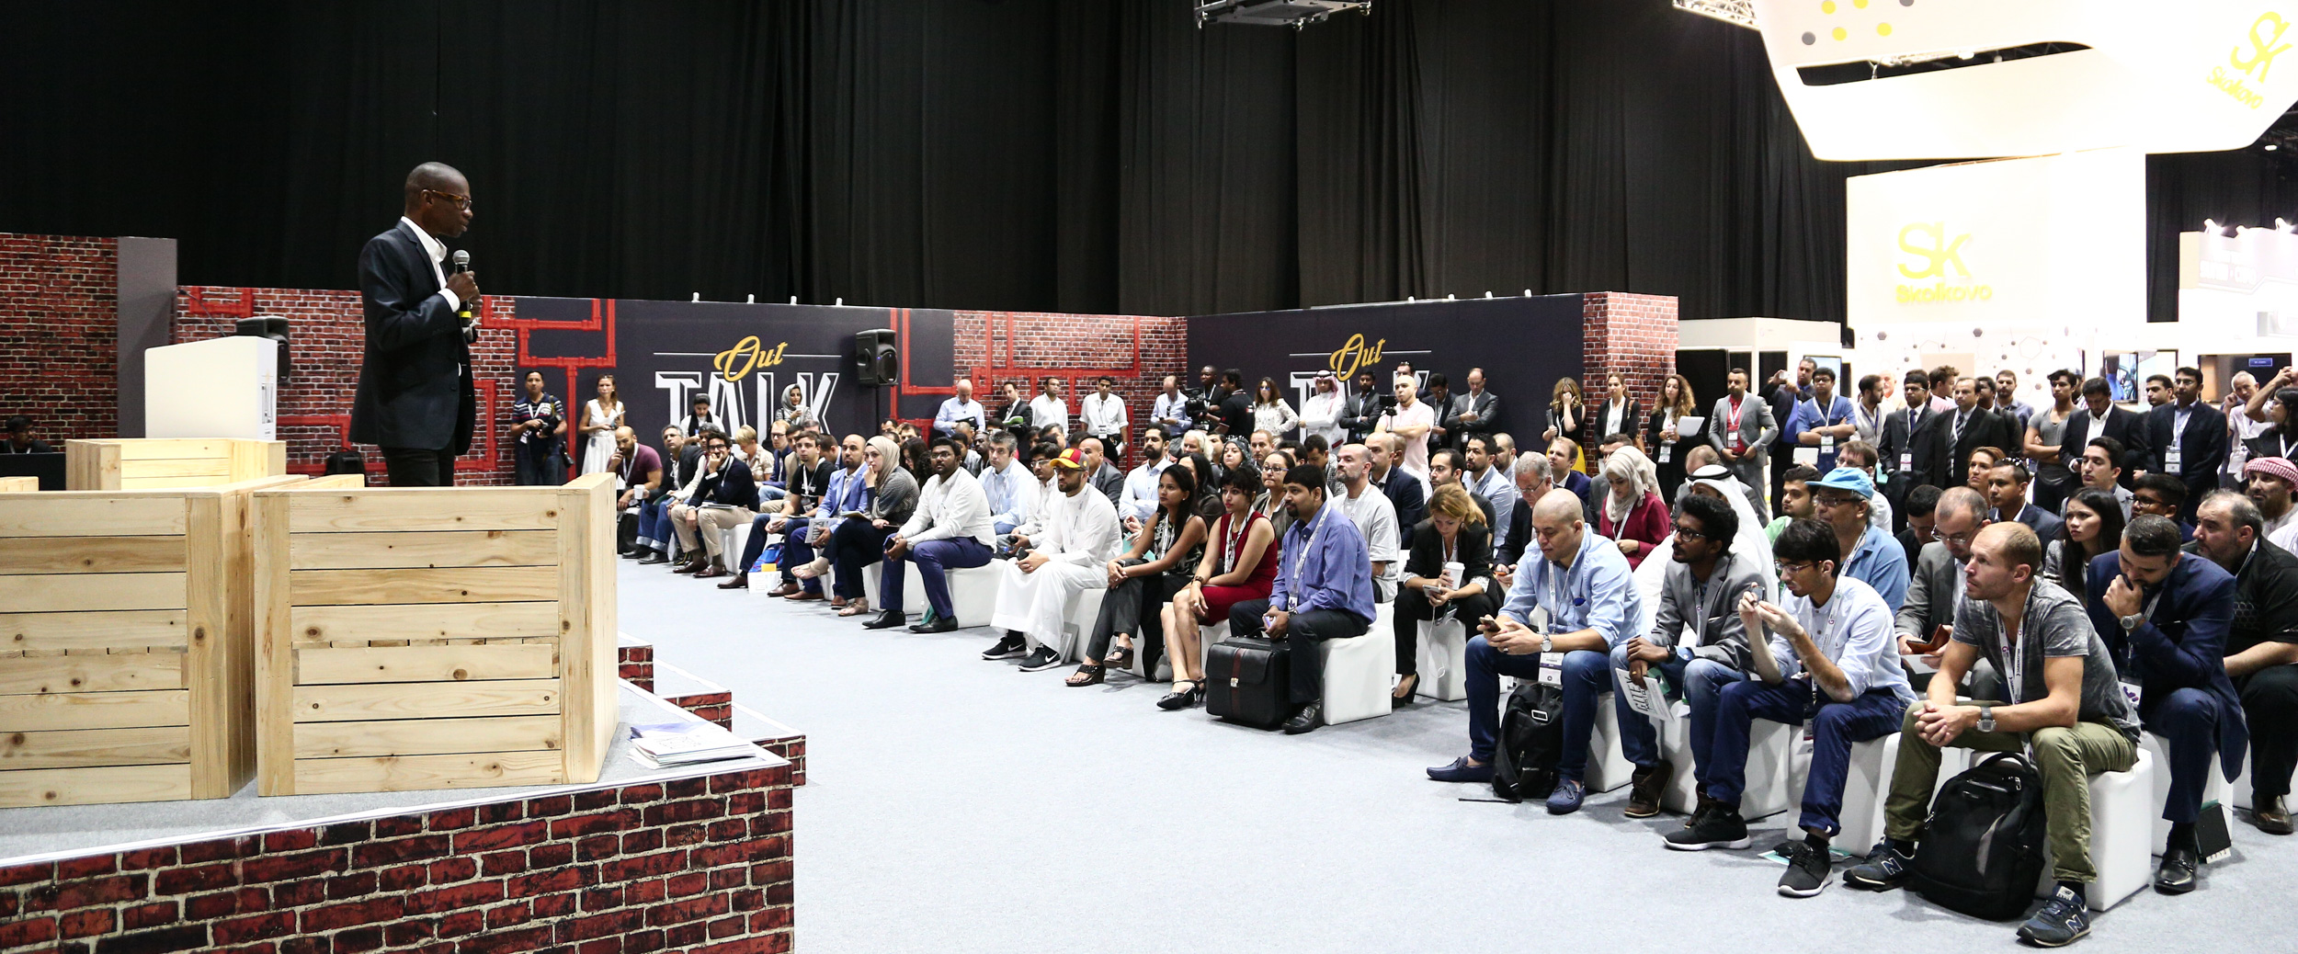
“GITEX Future Stars is designed to bring creative technologies and innovation to the forefront of the industry. The Dubai Tourism Futurism Competition will provide a stage for the world’s best travel technology startups to come together to enhance and disrupt technology solutions for travelers across the world. Dubai has long been a world leader in both technology and tourism, making it the ideal location to launch a global travel technology competition that is sure to enhance the way the world travels and support tourism in Dubai and beyond,” said Trixie LohMirmand, Senior Vice President, Events Management, Dubai World Trade Centre.

The Dubai Tourism Futurism Competition was launched at an exclusive Breakfast Workshop held on 31 July at Dubai World Trade Centre. The workshop, attended by over 100 participants, was led by Dubai Tourism representatives and industry experts including: Amadeus, Beco Capital, Roya, Startupbootcamp and Astrolabs. Offering insights into the challenges and opportunities for startups, a panel discussion during the workshop also shed light on potential gaps within the travel and tourism sectors that could pose as opportunities for startups to innovate.

The competition is currently open for submissions, and applications will be accepted until early September. To apply online, please visit: www.gitexfuturists.com/compete/dubai-tourism-competition

***

NOTES TO EDITORS

About Dubai’s Department of Tourism and Commerce Marketing (Dubai Tourism)
With the ultimate vision of positioning Dubai as the world’s leading tourism destination and commercial hub, Dubai Tourism’s mission is to increase the awareness of Dubai among global audiences and to attract tourists and inward investment into the emirate. Dubai Tourism is the principal authority for the planning, supervision, development and marketing of Dubai’s tourism sector. It markets and promotes the Emirate’s commerce sector, and is responsible for the licensing and classification of all tourism services, including hotels, tour operators and travel agents. Brands and departments within the Dubai Tourism portfolio include Dubai Business Events, Dubai Calendar, and Dubai Festivals and Retail Establishment (formerly known as Dubai Events and Promotions Establishment).

For further information, please contact:
Dubai Tourism
mediarelations@dubaitourism.ae
[+971] 600 55 5559
[+971] 4 201 7631

About GITEX Future Stars
GITEX Future Stars is Middle East and Africa's largest startup confluence of global tech entrepreneurs, international investors and influential corporate buyers. It is the biggest commercial sales platform for startups alongside GITEX Technology Week, the region's foremost tech sourcing and networking event featuring the biggest governments and private sector organizations participation.

