SUMMER AWARENESS CAMPAIGN HIGHLIGHTS DIVERSITY
OF DUBAI’S VALUE OFFERINGS AND EXPERIENCES
Six social media influencers from region take up tourism challenge to prove Dubai provides great value to visitors
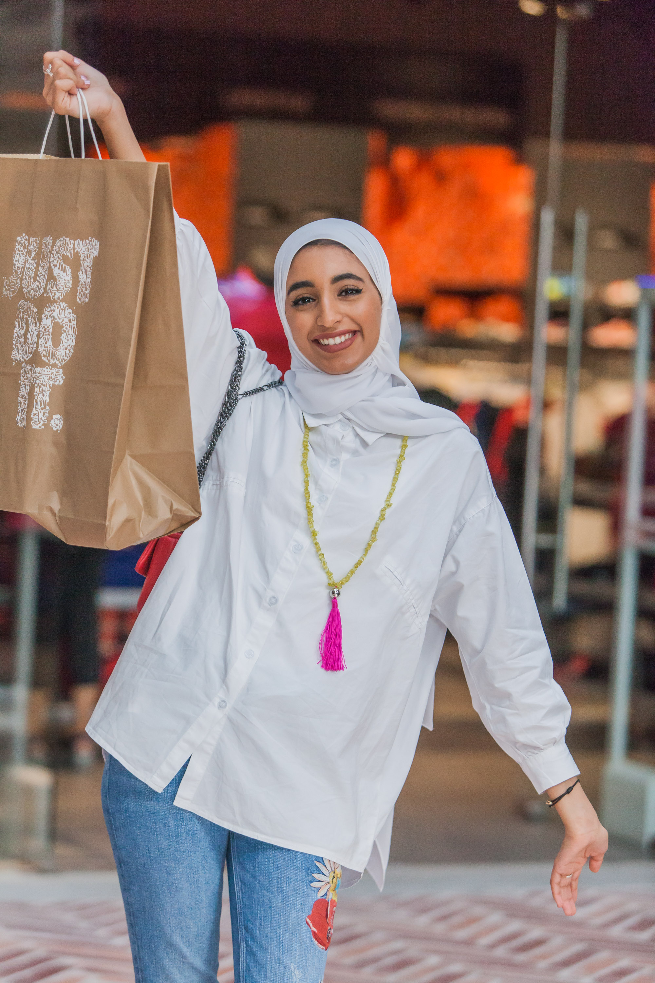
Dubai, United Arab Emirates; 30 August 2017: In an awareness campaign launched by the Department of Tourism and Commerce Marketing (Dubai Tourism) six young social media influencers from the region took part in the Dubai Summer Challenge to prove that Dubai provides great value to visitors. The project highlighted the diversity of value offerings and experiences that tourists can choose from during their stay in Dubai.

The initiative gave the six participating influencers - Ahmad Al Barqi, Rayan Khalid Alahmary, brothers Hassan Bin Mahfouz and Hussein Bin Mahfouz, Faisal Al Yammi (all from Saudi Arabia) and Kuwaiti national Hessa Al Khattaf - the opportunity to experience an amazing Dubai holiday with a budget of just AED3,000 each. For participants, a key objective was to

enjoy more for less with the ultimate champion being the one who was able to get the best value from the allocated budget.

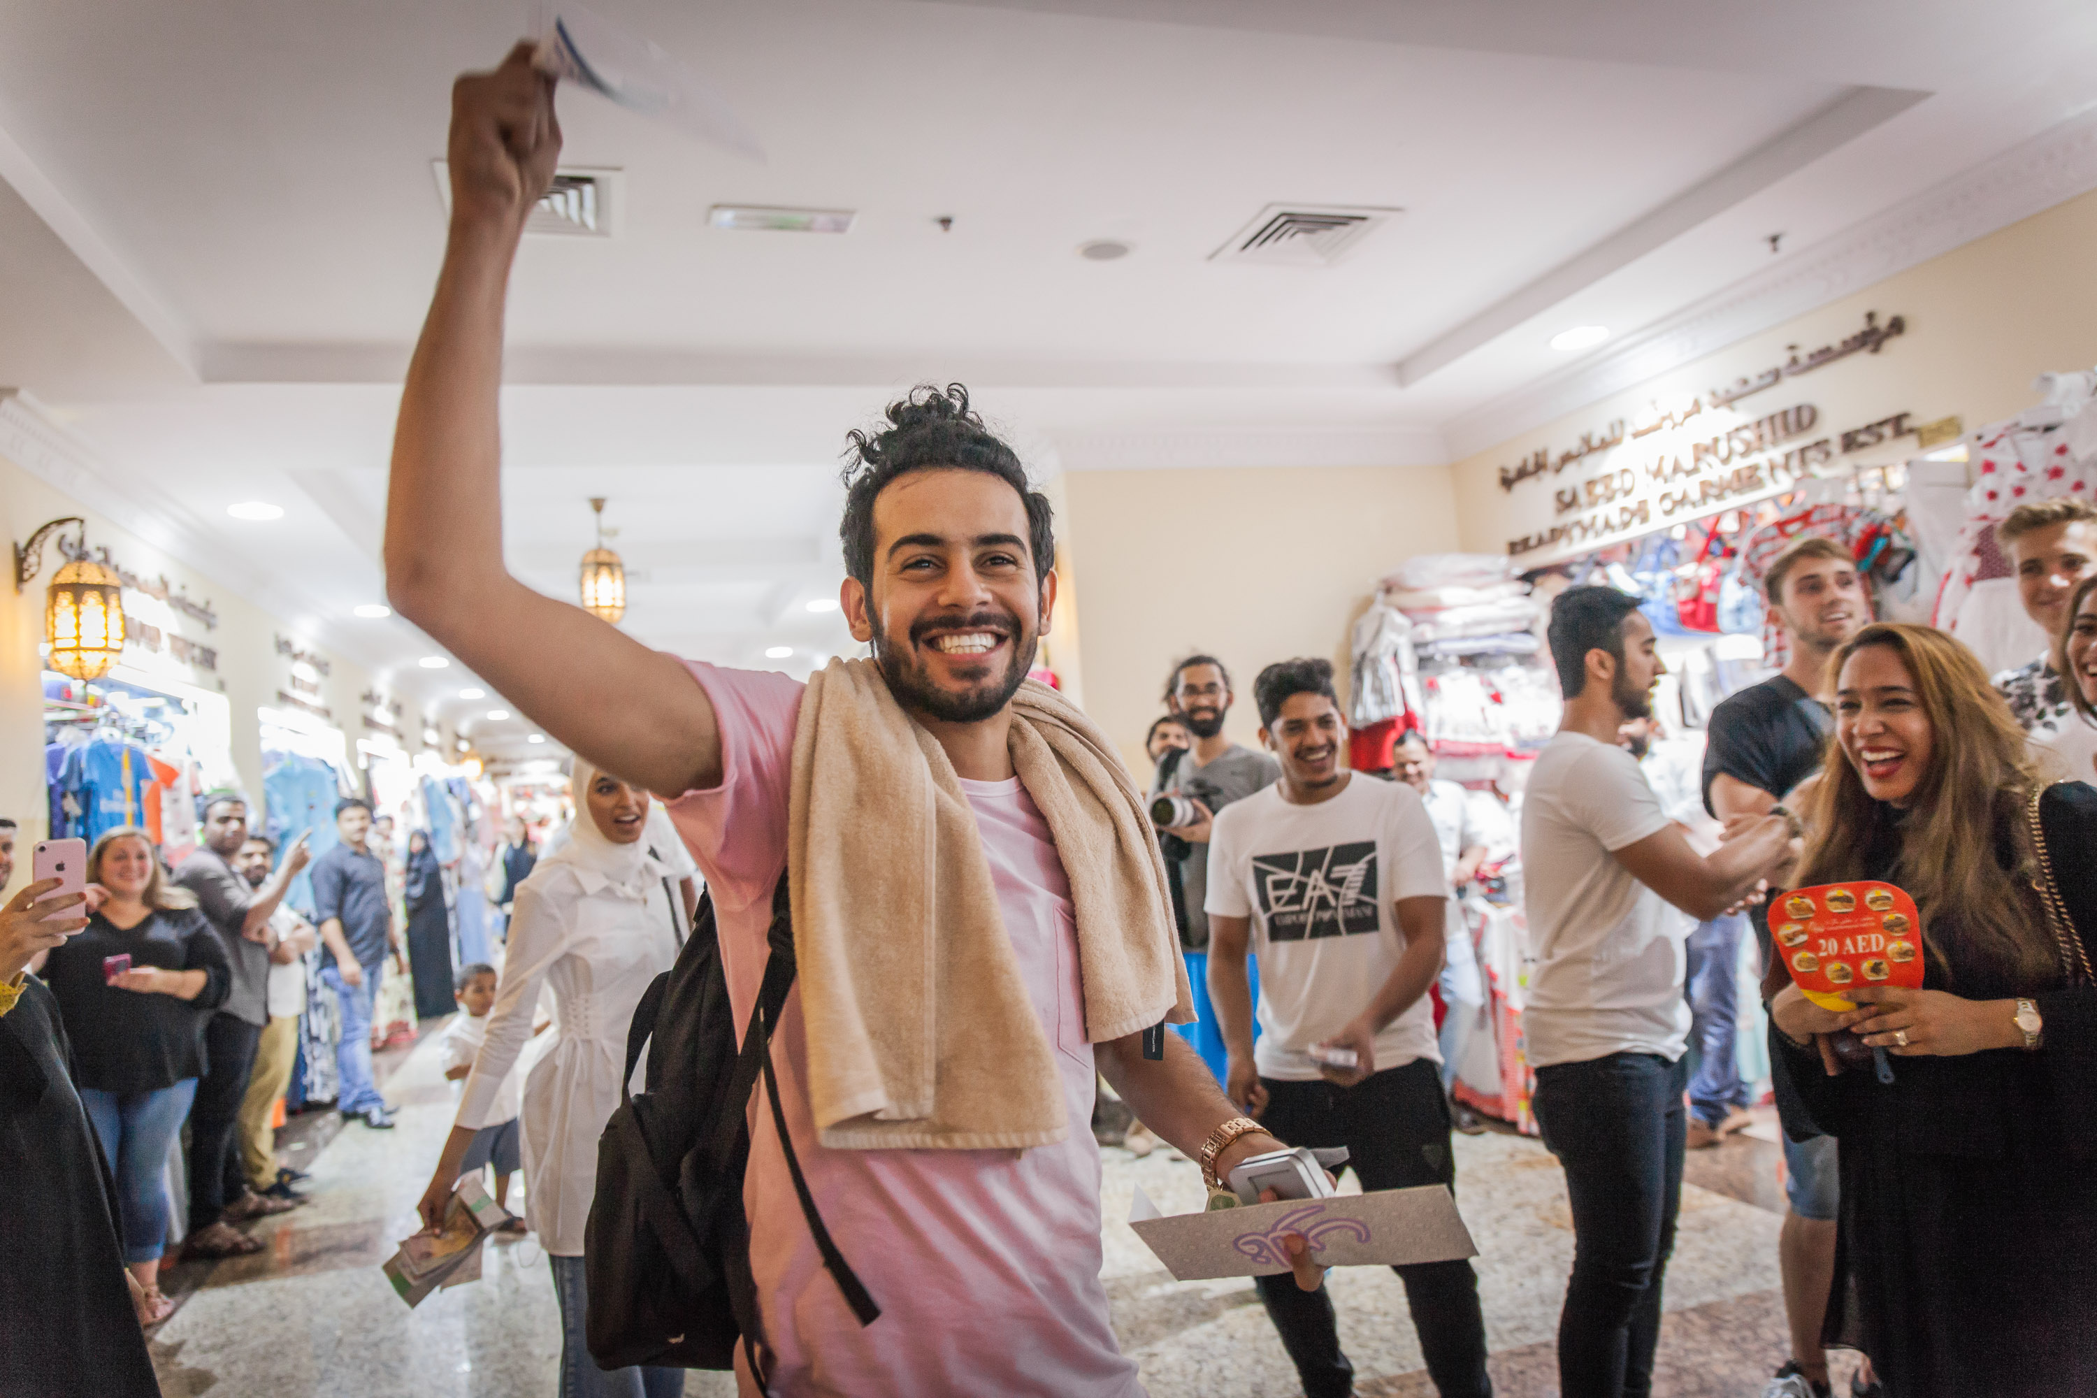
The challenge featured eight elements that participants had to cover or complete in Dubai within the AED3000 budget during their 3-day stay: Transportation (air tickets as well as domestic transport); accommodation; value for money shopping - highlighting Dubai’s value for money shopping experience at the ongoing Dubai Summer Surprises, as well as the DSS Pass featuring multiple deals and offers. This activity included a mandatory requirement - the purchase of at least one full outfit.

Participants also had to visit one new ticketed attraction that opened in the last 12 months; try at least three different types of cuisine; enjoy a cultural experience; and enjoy one attraction that offers free entry e.g. Dubai Fountain, Dubai Water Canal.

The final part of the challenge was to get the best bargain by visiting a designated Souk and purchasing a predetermined product at the lowest possible price that would demonstrate the participant’s bargaining skills. All participants managed to complete the eight tasks in the challenge without finishing their entire budget, giving them the opportunity to enjoy additional experiences.
The grand prize winner was Rayan Khalid Alahmary, who spent just AED1,733 in covering the eight tasks. Hassan Bin Mahfouz won the prize for the Best Bargain after purchasing a

fidget spinner, the predetermined item for purchase, for just AED 1 from Naif Souk, from the initial price of AED20.
Some of the Dubai landmarks, attractions and experiences selected for the challenge included Bollywood Parks and Legoland Waterpark in Dubai Parks and Resorts, IMG Worlds of Adventure, Outlet Village, Hub Zero at CITY WALK, Dubai Ice Rink at The Dubai Mall, the Sheikh Mohammed Centre for Cultural Understanding, Etihad Museum and Al Fahidi Historical Neighbourhood.
- Ends –

About Dubai’s Department of Tourism and Commerce Marketing (Dubai Tourism)
With the ultimate vision of positioning Dubai as the world’s leading tourism destination and commercial hub, Dubai Tourism’s mission is to increase the awareness of Dubai among global audiences and to attract tourists and inward investment into the emirate. Dubai Tourism is the principal authority for the planning, supervision, development and marketing of Dubai’s tourism sector. It markets and promotes the Emirate’s commerce sector, and is responsible for the licensing and classification of all tourism services including hotels, tour operators and travel agents. Brands and departments within the Dubai Tourism portfolio include Dubai Business Events, Dubai Calendar and Dubai Festivals and Retail Establishment.

