PRESS RELEASE
Dubai begins countdown to major auditing trade conference
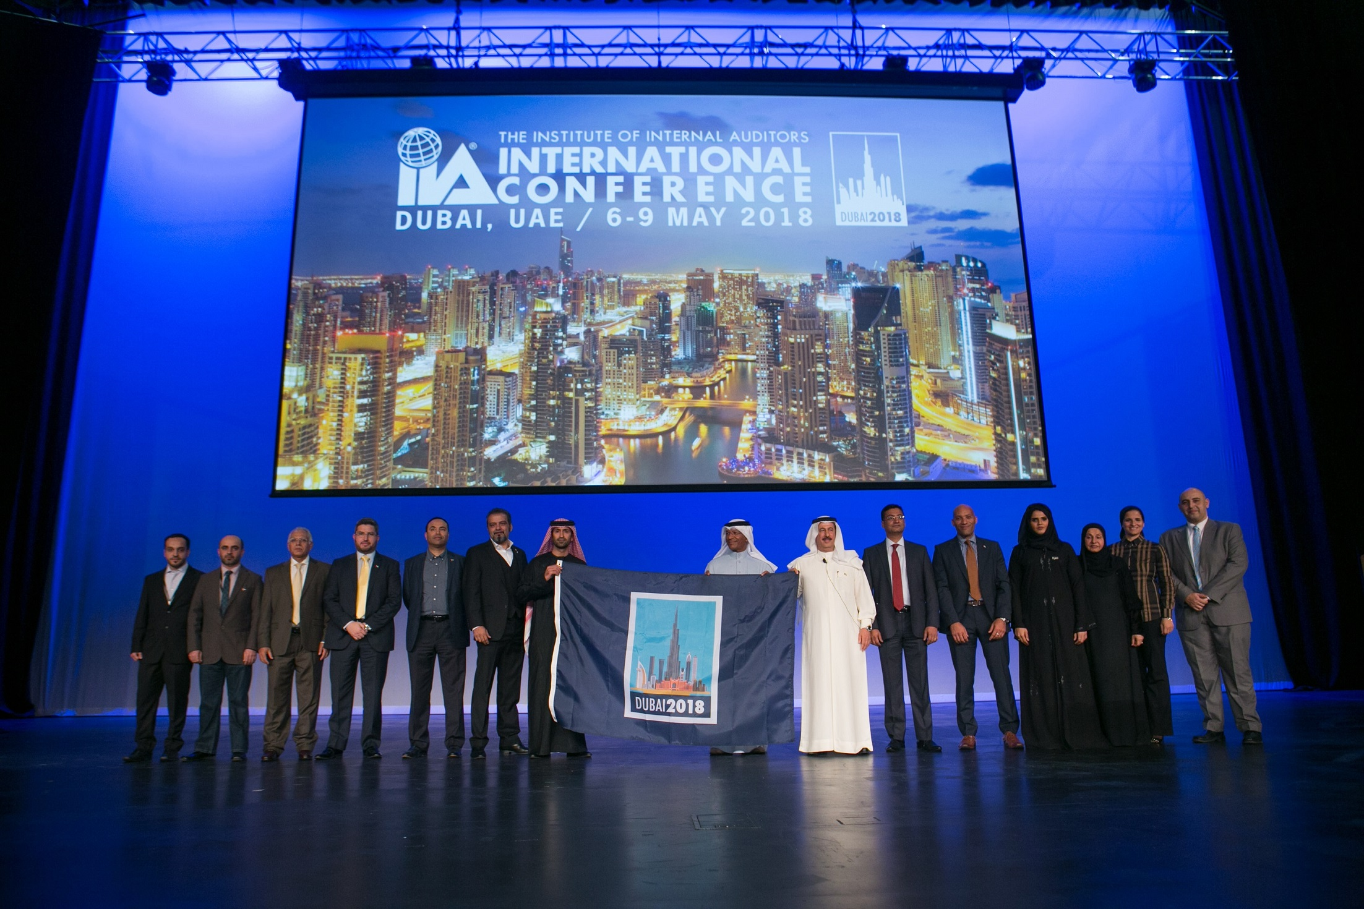
- The 2018 Institute of Internal Auditors International Conference, to be held under the patronage of His Highness Sheikh Mohammed bin Rashid Al Maktoum, Vice-President and Prime Minister of the UAE and Ruler of Dubai, is set to attract 3,500 delegates from 110 countries.

Dubai, United Arab Emirates: 31 July 2017: Under the patronage of His Highness Sheikh Mohammed bin Rashid Al Maktoum, Vice-President and Prime Minister of the UAE and Ruler of Dubai, the city is gearing up to host delegates from the Institute of Internal Auditors (IIA) at its International Conference, scheduled to take place in Dubai next year. Dubai Business Events (DBE), the city’s official convention bureau, collaborated with Dubai World Trade Centre (DWTC) and the UAE Internal Auditors Association (IAA) to successfully bid for the event.

With the 2017 International Conference concluding in Sydney, Australia, Dubai is accelerating preparations to host the 2018 conference, which is expected to attract approximately 3,500 delegates from 110 countries. The conference will take place at Dubai International Convention and Exhibition Centre, part of the Dubai World Trade Centre complex, from 6th – 9th May 2018.

Issam Kazim, Chief Executive Officer of Dubai Corporation for Tourism and Commerce Marketing, said: “Professional associations play a significant role in the growth of specific industries and make an important contribution towards knowledge-sharing and industry progression around the globe. As we work to strengthen Dubai’s reputation as an ideal destination to host business events, and most importantly, a global knowledge hub, business events such as the IIA International Conference further fuel our journey towards achieving our goal.”

The IIA is an international professional association headquartered in Florida, USA, with over 185,000 members around the globe. Established in 1941, the authority comprises members who work in internal auditing, risk management, governance, internal control, information technology audit, education, and security.

Themed ‘Connecting the World Through Innovation’, the 2018 IIA International Conference in Dubai will lay emphasis on innovation, and tackle current technology issues that affect the internal audit profession. The event will offer a unique platform for members from around the world to connect with thought leaders and discover insights on matters pertaining to the profession. The customisable agenda will feature a variety of educational sessions for varying levels – from CAEs and heads of internal audit, to directors, managers and audit staff.

Dubai had an extremely strong presence at this year’s International Conference in Sydney, supported by the UAE Embassy in Australia, and the travelling delegation included:
- Guest of Honour Matar Al Mansoori, UAE Counsellor to Australia, who received the international conference flag on behalf of the UAE
- Abdulqader Obaid Ali, President of UAE IAA
- Ayesha Bin Lootah, Deputy Director – Internal Audit, Department of Tourism and Commerce Marketing and Board of Governors Member at the UAE IAA
- Samia Al Yousuf, General Manager of UAE IAA
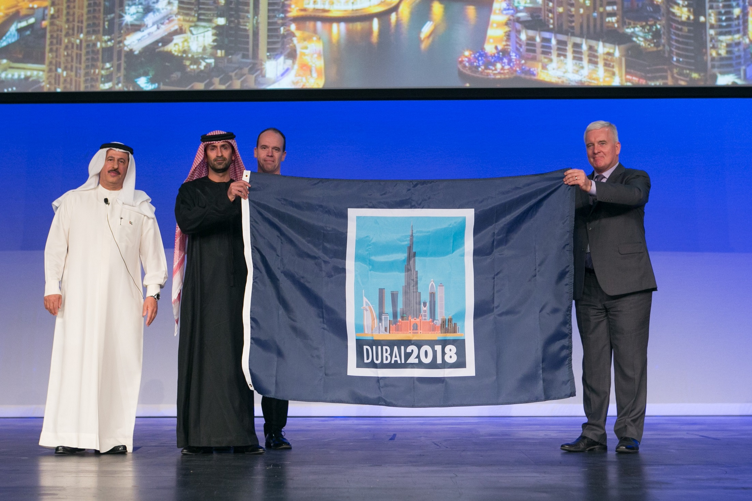
Matar Al Mansoori, UAE Counsellor to Australia, said: “International conferences play a crucial role in promoting the UAE to a global audience and attracting business interest in a broad range of sectors. As our economy diversifies and grows, events such as the IIA International Conference 2018 will continue put the spotlight on our competitive business environment and the opportunities in the UAE.

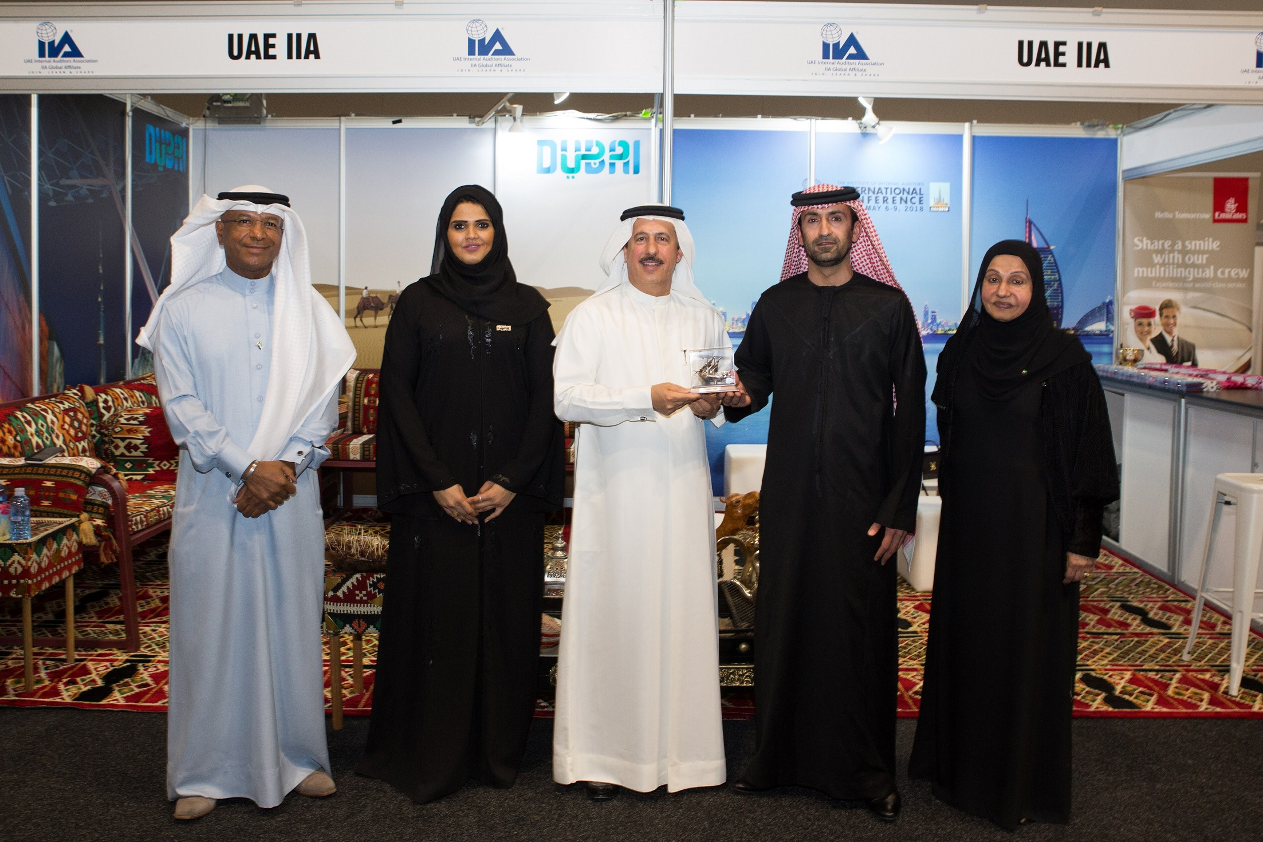
“The UAE’s representation here in Sydney and the official handover of this event to Dubai is another example of the strong and fruitful relationships we have internationally.”

Ayesha Bin Lootah, Deputy Director – Internal Audit, Department of Tourism and Commerce Marketing, Dubai, and Board of Governors Member at the UAE IAA Board of Governance said: “We aim to see Dubai become the leading destination for international conferences and we are privileged to host the 2018 IIA International Conference in Dubai. The internal audit network is growing tremendously around the globe, and its significance is being increasingly recognised by government institutions and the private sector, including small, medium and larger corporations. The 2018 conference will shed light on current scenarios, trends and world class insight, while offering the opportunity for members to network.”

Abdulqader Obaid Ali, President of UAE IAA, said: “Having successfully bid for the 2018 IIA International Conference in partnership with key stakeholders in Dubai, preparations are already well underway to ensure the event is a success. We expect to break all previous records in terms of number of attendees, and the topics will emphasize the key dynamic changes in the environment considering cyber and technology threats.

“As an organisation, one of our key goals is to promote and contribute to the increased awareness of internal auditing in the region, and next year’s event will play a vital role in achieving this. We look forward to welcoming our peers from around the world to exchange knowledge and make sure the conference leaves a strong legacy.”

***

NOTES TO EDITORS
About Dubai Business Events – the Official Convention Bureau
Dubai Business Events (DBE) – the Official Convention Bureau, aims to further develop and increase Dubai's share of the international business events market in order to grow economic development, jobs and knowledge creation in the emirate. DBE’s main goal, as a division of Dubai Tourism, is to establish the Emirate as a premier business event destination by helping organizers of international meetings, incentives, congresses and exhibitions plan and manage every aspect of their event. As a member of BestCities Global Alliance DBE aim to deliver the world's best service experience for the meeting industry.

About Dubai’s Department of Tourism and Commerce Marketing (Dubai Tourism)
With the ultimate vision of positioning Dubai as the world’s leading tourism destination and commercial hub, Dubai Tourism’s mission is to increase the awareness of Dubai among global audiences and to attract tourists and inward investment into the emirate. Dubai Tourism is the principal authority for the planning, supervision, development and marketing of Dubai’s tourism sector. It markets and promotes the Emirate’s commerce sector, and is responsible for the licensing and classification of all tourism services, including hotels, tour operators and travel agents. Brands and departments within the Dubai Tourism portfolio include Dubai Business Events, Dubai Calendar, and Dubai Festivals and Retail Establishment (formerly known as Dubai Events and Promotions Establishment).

For further information, please contact:
Dubai Tourism
mediarelations@dubaitourism.ae
[+971] 600 55 5559
[+971] 4 201 7631

