DUBAI’S SUCCESSFUL 2016/2017 CRUISE SEASON WEIGHS ANCHOR

- 157 ships and over 625,000 tourists welcomed to Dubai this cruise season
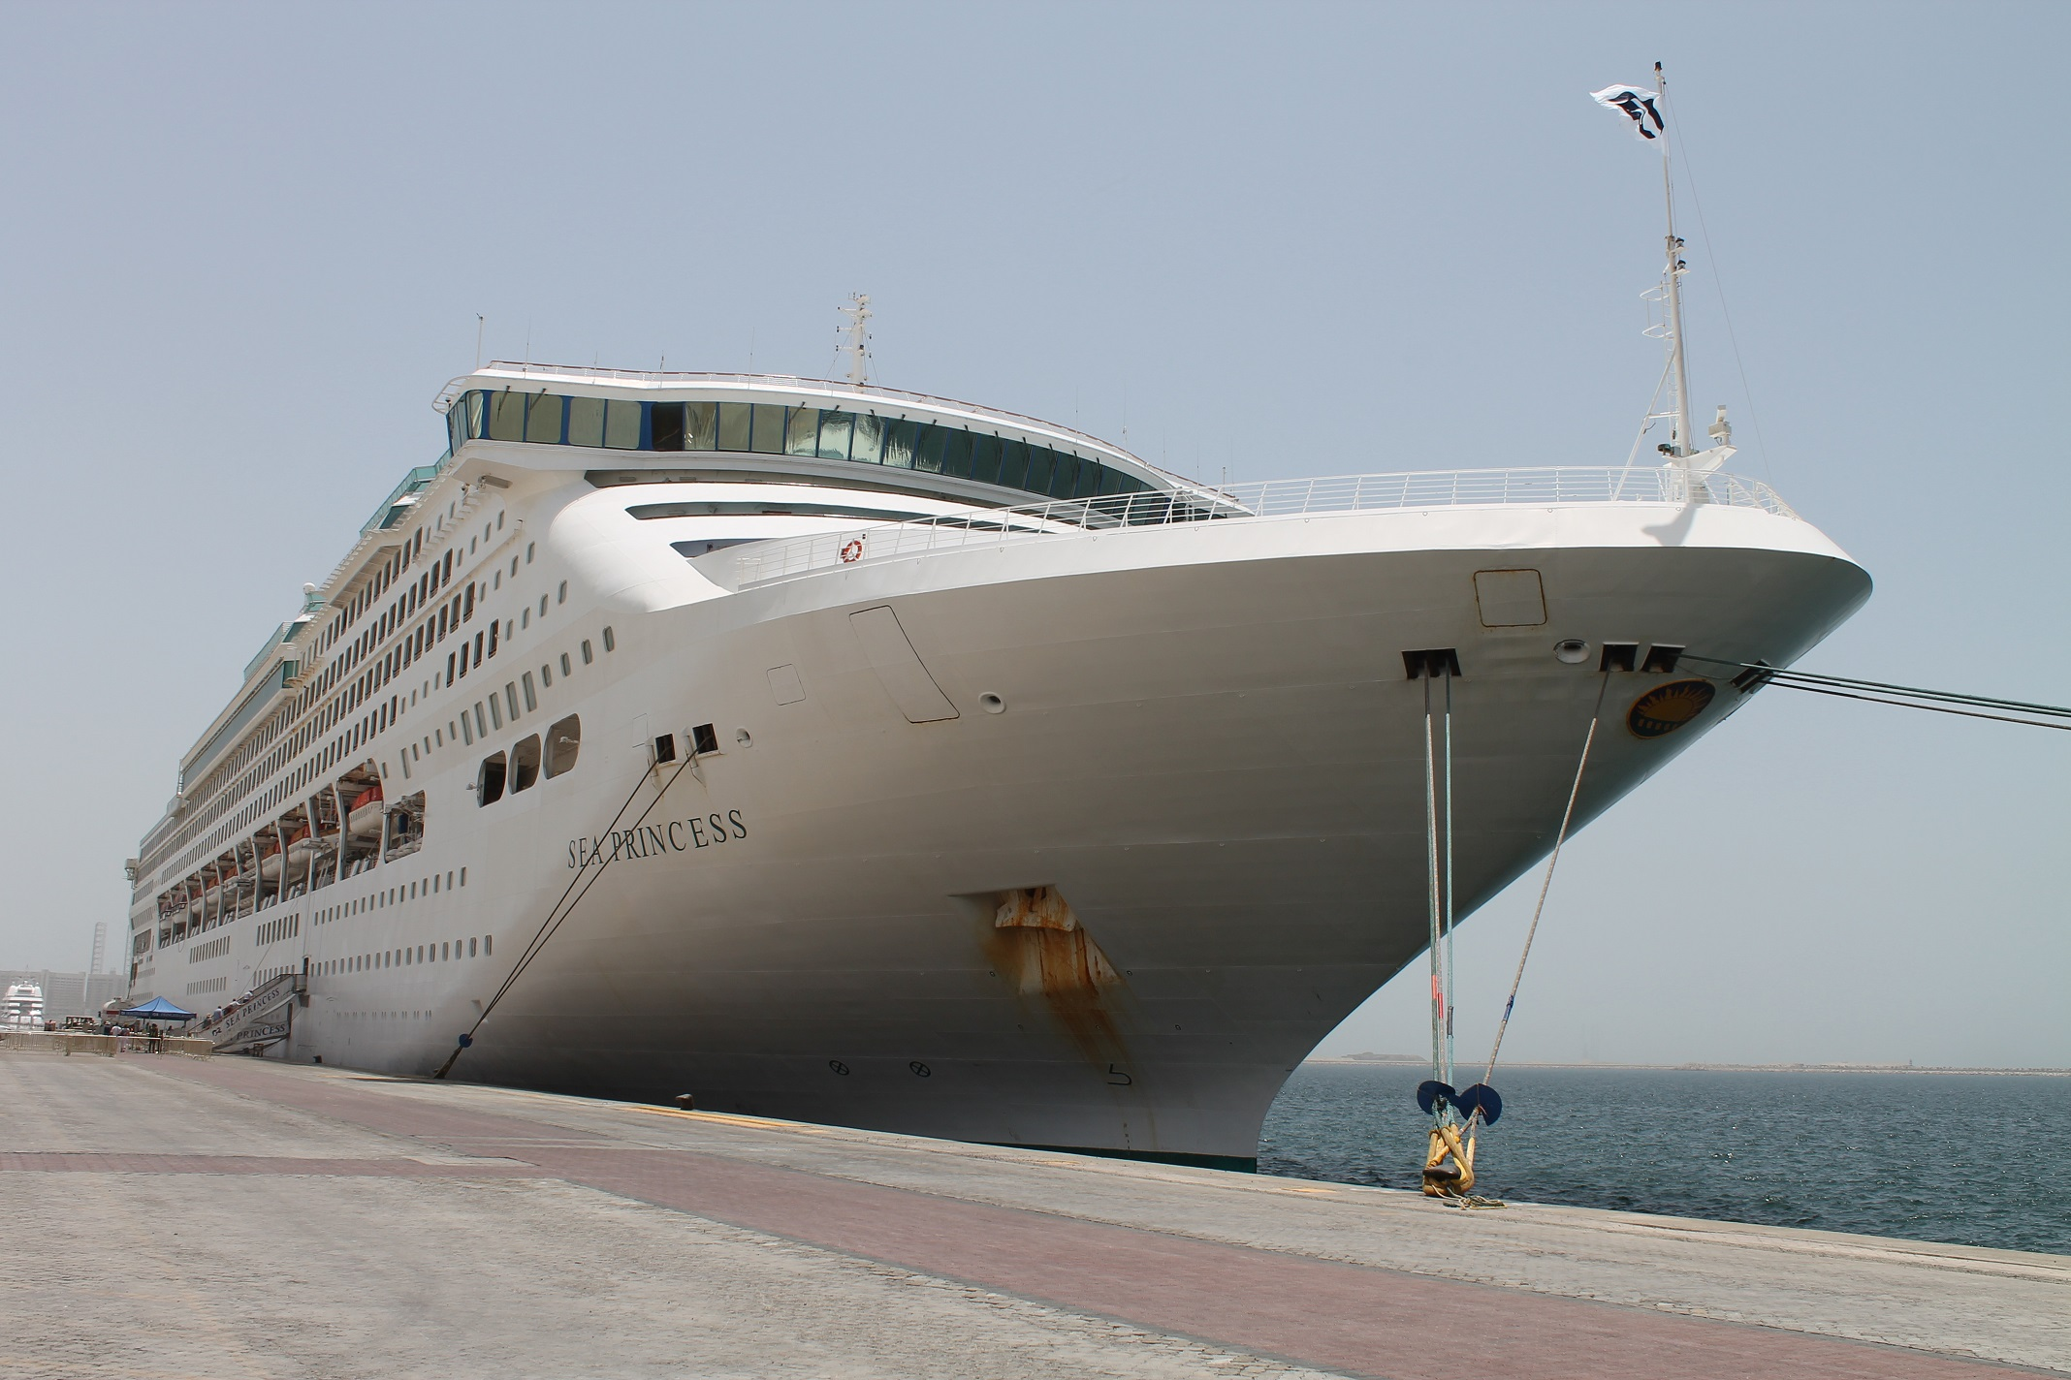
- Dubai Cruise Tourism reveals a 15 per cent increase in visitors compared to the previous season

Dubai, United Arab Emirates; 28 June 2017: The 2016/2017 Dubai Cruise season officially concluded with the departure of the season’s final ship, the C.S. Sea Princess, from Port Rashid recently. After a stopover in Dubai, the luxury ship’s only port of call in the GCC, the C.S. Sea Princess continued her voyage to Aqaba as part of a 104-nights round trip around the world.

This marked the end of a successful season for Dubai Cruise Tourism, which saw over 625,000 cruise tourists visit the city via a total of 157 ship calls, reflecting an increase of 15 per cent and 18 per cent respectively when compared to the 2015/2016 season. The season also saw Thomson Cruises, the first UK-based cruise line home porting in the region, in addition to inaugural visits from TUI’s Mein Schiff 1 Norwegian Cruise Line’s Norwegian Star and MSC’s MSC Fantasia among the eight other maiden ship calls.

Commenting on the success of the 2016/2017 season, Jamal Humaid Al Falasi, Director of Dubai Cruise Tourism said: “We are very pleased with the success of our 2016/2017 cruising season, and with the city’s sustained popularity as a winter cruise destination. We are grateful to DP World, Dubai Airports, Dubai Immigration, Dubai Customs, Emirates Airlines and our other key public and private sector stakeholders for their continued cooperation which has led to an ever-increasing number of cruise operators looking to anchor in the emirate. Bolstered by our recent success and our upcoming partnerships over the coming seasons, we are confident we will achieve our strategic goal of welcoming 1 million cruise tourists to Dubai by 2020/ 21 cruise season.”

The C.S. Sea Princess, an 857 feet-long ship from Princess Cruises, made her way to Dubai from Colombo, bringing almost 3,000 cruise tourists to the city. Her stop in Dubai was in close succession to one made earlier by her sister ship from Princess Cruises; the C.S. Majestic Princess a brand-new vessel, built in Italy earlier this year, making its maiden call to Dubai carrying over 3,500 passengers and over 1,300 crew.

The Dubai Cruise 2017/2018 season is set to commence on 25th October, with the arrival of cruise ship Seabourn Encore. More recently, Dubai Cruise also announced that P&O Cruises would be home porting in Dubai for the first time during the 2018/2019 season.

- Ends -

About Dubai’s Department of Tourism and Commerce Marketing (Dubai Tourism)
With the ultimate vision of positioning Dubai as the world’s leading tourism destination and commercial hub, Dubai Tourism’s mission is to increase the awareness of Dubai among global audiences and to attract tourists and inward investment into the emirate.

Dubai Tourism is the principal authority for the planning, supervision, development and marketing of Dubai’s tourism sector. It markets and promotes the Emirate’s commerce sector, and is responsible for the licensing and classification of all tourism services including hotels, tour operators and travel agents. Brands and departments within the Dubai Tourism portfolio include Dubai Business Events, Dubai Calendar and Dubai Festivals and Retail Establishment.

FOR FURTHER INFORMATION PLEASE CONTACT:

Dubai Tourism
mediarelations@dubaitourism.ae
[+971] 600 55 5559
[+971] 4 201 7631

