PRESS RELEASE
Dubai now among top 10 destinations
for international meetings
- 2016 saw 24% growth in the total number of international meetings over 2015, according to UIA rankings. 138% growth achieved since 2012
Dubai, United Arab Emirates: 13 June 2017: Dubai has emerged as one of the top 10 destinations for international meetings, according to the latest edition of the International Meetings Statistics Report published last week by Union of International Associations (UIA). The report ranked 1,157 cities globally based on the total number of international meetings that took place during the year. Previously ranked 14th in the 2015 edition, Dubai has moved up the list to claim the 10th spot with a total of 180 meetings taking place in 2016, reflecting a growth of 24% in comparison to 2015.
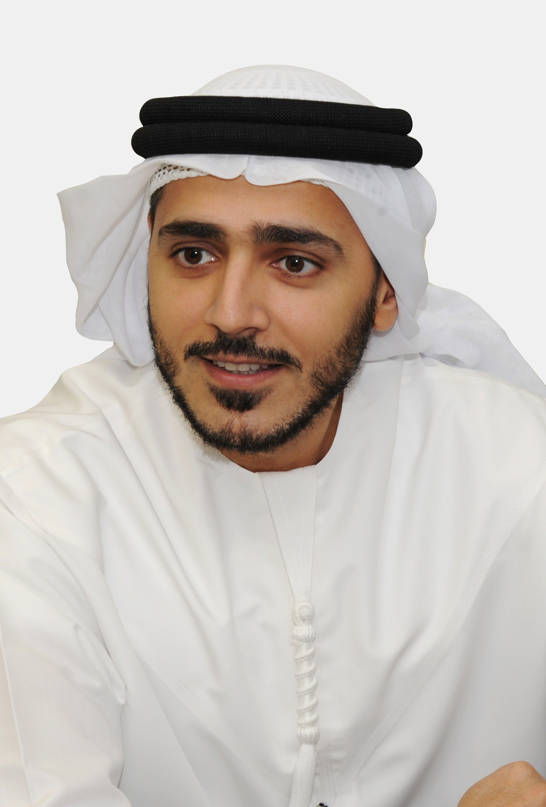
Dubai is the only city in the Middle East and Africa to appear in the top 25 in the rankings, further underlining its status as the region’s number one destination for international meetings and conferences.
Issam Kazim, Chief Executive Officer of Dubai Corporation for Tourism and Commerce Marketing, said: “With these latest UIA rankings it is once again clear that Dubai is now not only the regional leader in the sector, but also a major destination on the global stage for business events. We will continue to strengthen our business events offering, and strive towards transforming Dubai into a global knowledge hub.”
The total number of meetings assessed include those that are organised by international organisations, as well as ones organised by national organisations or branches but with significant international character. Dubai’s current standing reaffirms the city’s status of being a premier destination to host business events, and reflects the tremendous growth experienced over the past five years. In 2012, Dubai ranked 26th with a total of 76 international meetings that took place in the city. Dubai’s business events offering has since evolved; the city’s world-class infrastructure and global connectivity adds to the overall appeal resulting in a 138% increase in international meetings hosted since 2012.
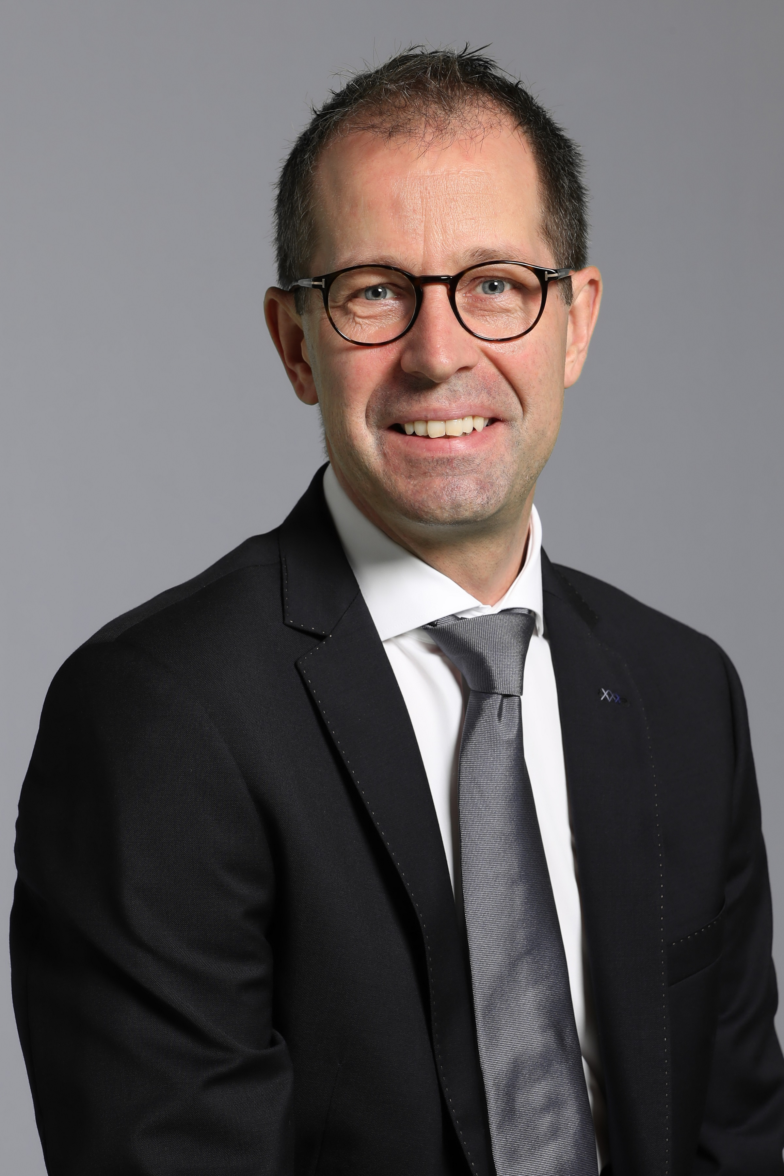
Steen Jakobsen, Director, Dubai Business Events, said: “Dubai’s business events industry has undoubtedly grown over the past decade, and we are very proud that the city is being regarded as one of the top 10 international meetings destinations by UIA, competing with over 1,100 worldwide destinations for the spot. We have worked very hard to achieve this status, with strong support from public and private partners, including Dubai World Trade Centre, hotels, Emirates Airlines, flydubai and other meetings industry suppliers, and are aiming to continue enhancing our offering to remain competitive and further propel Dubai’s ranking in the years to come.”
The latest UIA rankings report comes on the back of Dubai’s recent announcement to launch the Dubai Association Conference which will be held on 11-12 December 2017 at the Dubai World Trade Centre. A first-of-a-kind in the region, the conference acknowledges the crucial role associations play in Dubai’s socio-economic development and its transition to a knowledge-based economy. Guided by the theme of ‘Building a Community’, the Dubai Association Conference will host association executives from regional and international associations, government representatives, university faculties and students as well as other professionals who are keen to develop associations.
In addition to the Dubai Association Conference, Dubai is also set to host key international business events this year, including: Academy of International Business Annual Meeting, Fédération Internationale des Déménageurs Internationaux (FIDI) Annual Conference, Annual Congress of the Asia Pacific League of Associations for Rheumatology, and the International Primary Immunodeficiencies Congress.
***
NOTES TO EDITORS
About Dubai Business Events – the Official Convention Bureau
Dubai Business Events (DBE) – the Official Convention Bureau, aims to further develop and increase Dubai's share of the international business events market in order to grow economic development, jobs and knowledge creation in the emirate. DBE’s main goal, as a division of Dubai Tourism, is to establish the Emirate as a premier business event destination by helping organizers of international meetings, incentives, congresses and exhibitions plan and manage every aspect of their event. As a member of BestCities Global Alliance DBE aim to deliver the world's best service experience for the meeting industry.

About Dubai’s Department of Tourism and Commerce Marketing (Dubai Tourism)
With the ultimate vision of positioning Dubai as the world’s leading tourism destination and commercial hub, Dubai Tourism’s mission is to increase the awareness of Dubai among global audiences and to attract tourists and inward investment into the emirate.

Dubai Tourism is the principal authority for the planning, supervision, development and marketing of Dubai’s tourism sector. It markets and promotes the Emirate’s commerce sector, and is responsible for the licensing and classification of all tourism services including hotels, tour operators and travel agents. Brands and departments within the Dubai Tourism portfolio include Dubai Business Events, Dubai Calendar and Dubai Festivals and Retail Establishment.

For further information, please contact:
Dubai Tourism
mediarelations@dubaitourism.ae
[+971] 600 55 5559
[+971] 4 201 7631

