Press Release

SHAH RUKH KHAN BACK IN DUBAI TO SHOOT SEQUEL TO AWARD-WINNING #BEMYGUEST FILM
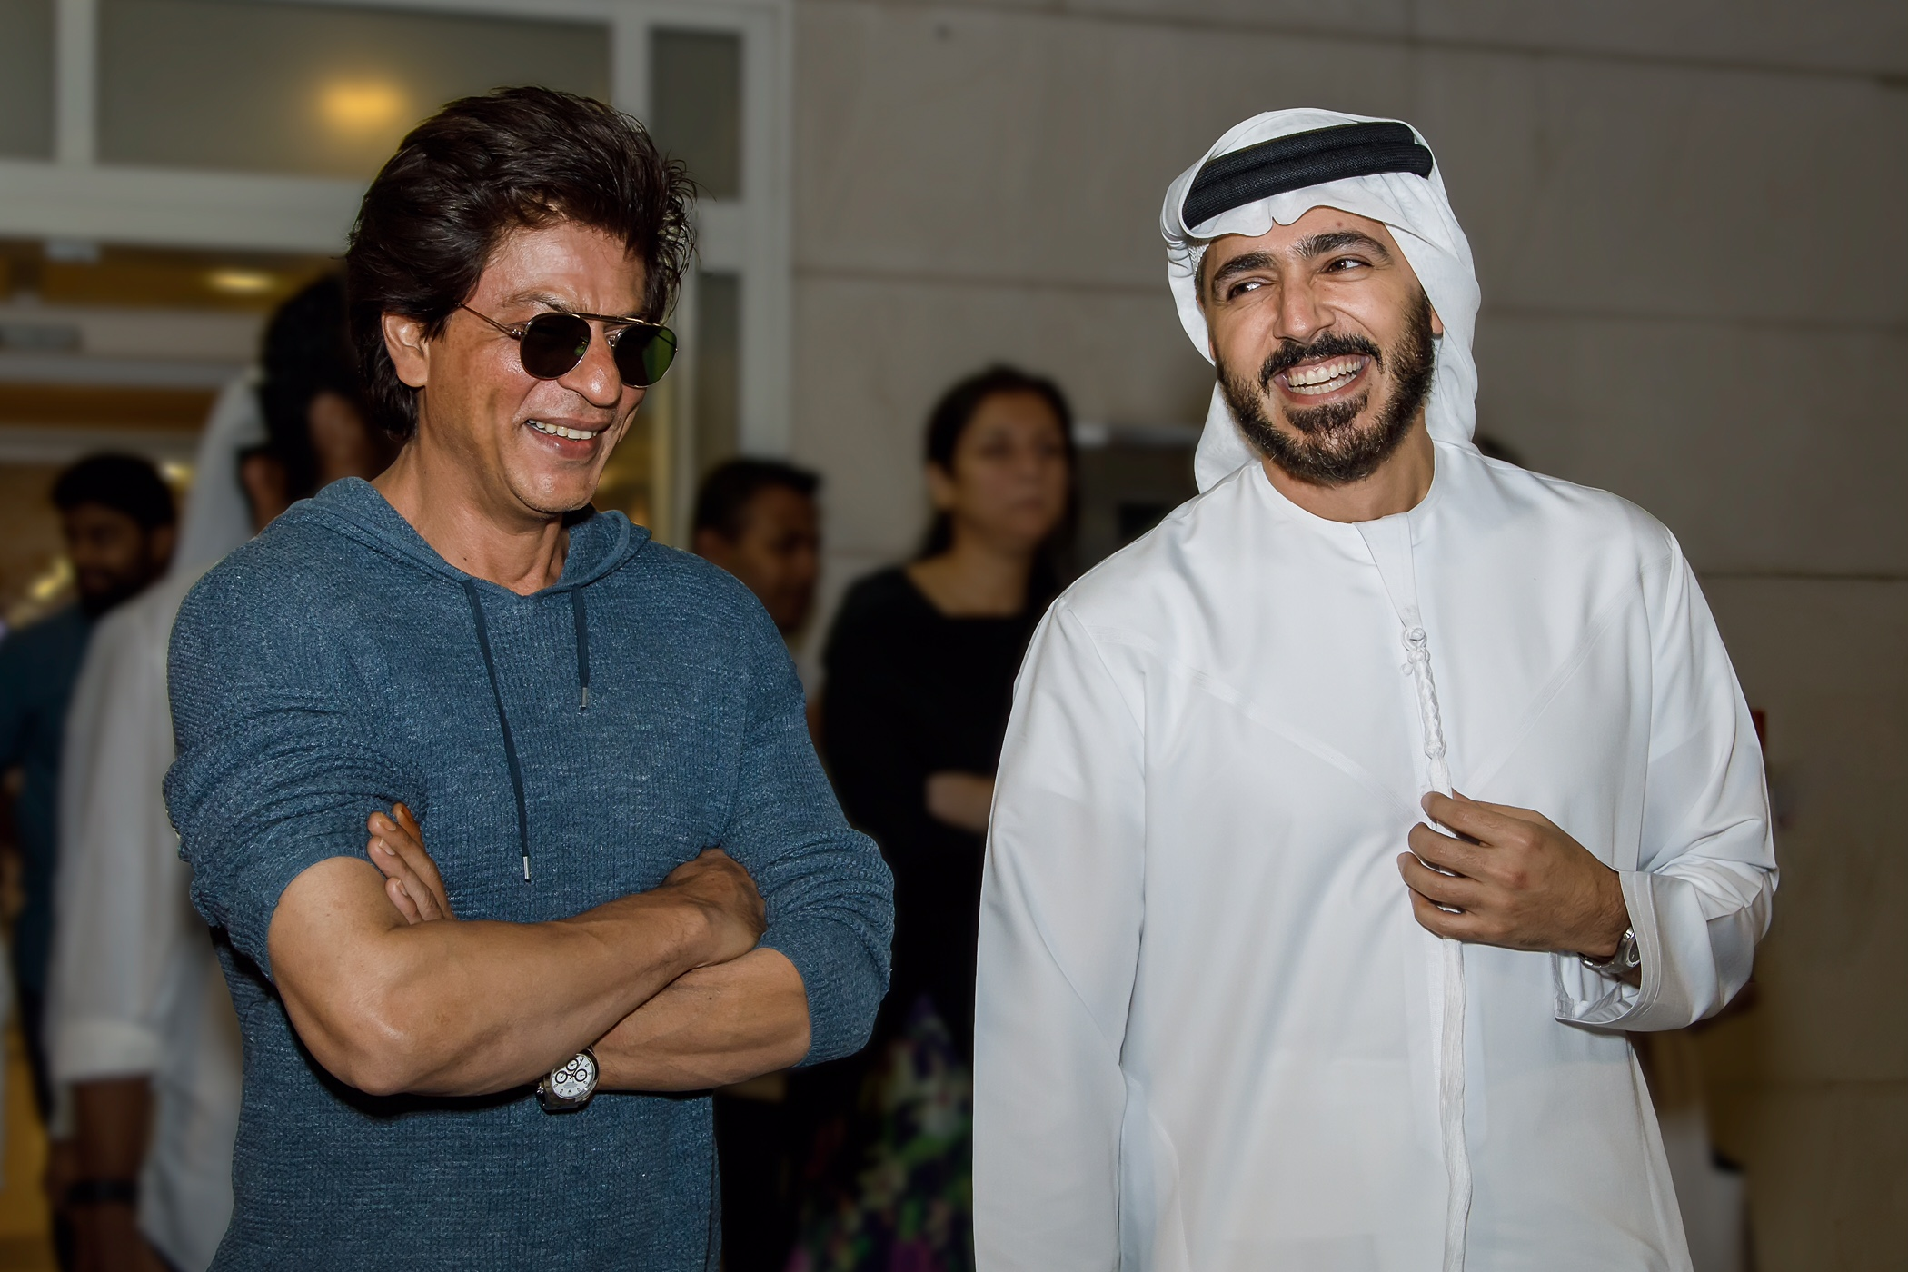
Dubai, UAE, 7 May 2017: Bollywood icon Shah Rukh Khan arrived in Dubai on 6 May to shoot the sequel to the award-winning #BeMyGuest film with the second phase of the promotional campaign film to be done in collaboration with well-known Indian film director Kabir Khan.

With millions of fans around the world faithfully following his every move, Shah Rukh Khan, or SRK, will continue his exciting journey in Dubai in his own inimitable style, as he shines a light on the multidimensional and multicultural character of a bustling metropolis that he considers his second home.

On arrival at Dubai International Airport, Shah Rukh Khan was welcomed by Issam Kazim, CEO, Dubai Corporation for Tourism and Commerce Marketing (DCTCM), and they also took the opportunity to discuss future collaboration.

#BeMyGuest is a film produced by Dubai’s Department of Tourism and Commerce Marketing (Dubai Tourism) to further enhance the emirate’s position as a ‘must-visit’ destination and attract even more tourists from India, a key source market for Dubai’s tourism industry, and around the world.

Expressing his delight to be back in Dubai, Shah Rukh Khan said he was happy to be
filming the sequel to the hugely successful #BeMyGuest campaign film. He said that the film was done in a creative and different way from how tourism films are usually made, as it was “so funny and sweet” yet it was still able to showcase Dubai in all its glory.

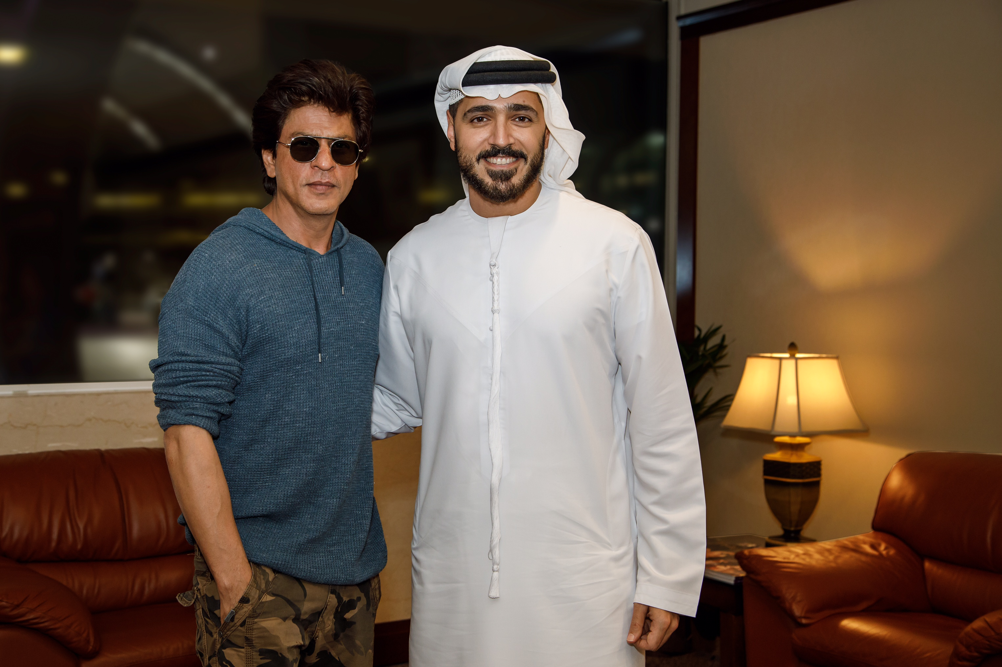
“I think it is really nice, I really enjoyed making it and happy we are making another one, “ he said, and added: “I am not an advocate for Dubai because I have done Dubai Tourism films, I genuinely like being in Dubai, I think it’s a really wonderful place, it’s a fantastic city…It has everything for everyone.”

Since its launch in December 2016, #BeMyGuest has garnered 45 million views across multiple social media channels as well as 65 million engagements from around the world. #BeMyGuest also reached No.3 on YouTube’s worldwide trending list within 48 hours of its launch, becoming one of the top 10 most viewed videos on the website globally in December. The film has also won international awards including the Grand Prix at the International Tourism Film Festival, “Tourfilm Riga” held in Latvia and the Diamond Award at ITB Berlin’s “Golden City Gate” tourism awards.

- ends –

About Dubai’s Department of Tourism and Commerce Marketing (Dubai Tourism)
With the ultimate vision of positioning Dubai as the world’s leading tourism destination and commercial hub, Dubai Tourism’s mission is to increase the awareness of Dubai among global audiences and to attract tourists and inward investment into the emirate.

Dubai Tourism is the principal authority for the planning, supervision, development and marketing of Dubai’s tourism sector. It markets and promotes the Emirate’s commerce sector, and is responsible for the licensing and classification of all tourism services, including hotels, tour operators and travel agents. Brands and departments within the Dubai Tourism portfolio include Dubai Business Events, Dubai Calendar, and Dubai Festivals and Retail Establishment.

For further information, please contact:
Dubai Tourism
mediarelations@dubaitourism.ae
[+971] 600 55 5559
[+971] 4 201 7631

