Press Release

SHAH RUKH KHAN PAYS A VISIT TO AL JALILA CHILDREN’S SPECIALTY HOSPITAL IN SPIRIT OF UAE YEAR OF GIVING

SRK spent time with children during special visit to hospital while in Dubai shooting sequel to the successful #BeMyGuest campaign film for Dubai Tourism

Dubai, UAE: 8 May, 2017: Bollywood legend Shah Rukh Khan, or SRK, paid a surprise visit to Al Jalila Children’s Specialty Hospital – UAE’s first paediatric hospital, on 7 May, in keeping to the spirit of the UAE’s Year of Giving. SRK toured the hospital, getting a first-hand insight into its ultramodern facilities and spent time meeting some of its young inpatients and enquiring about their well-being.
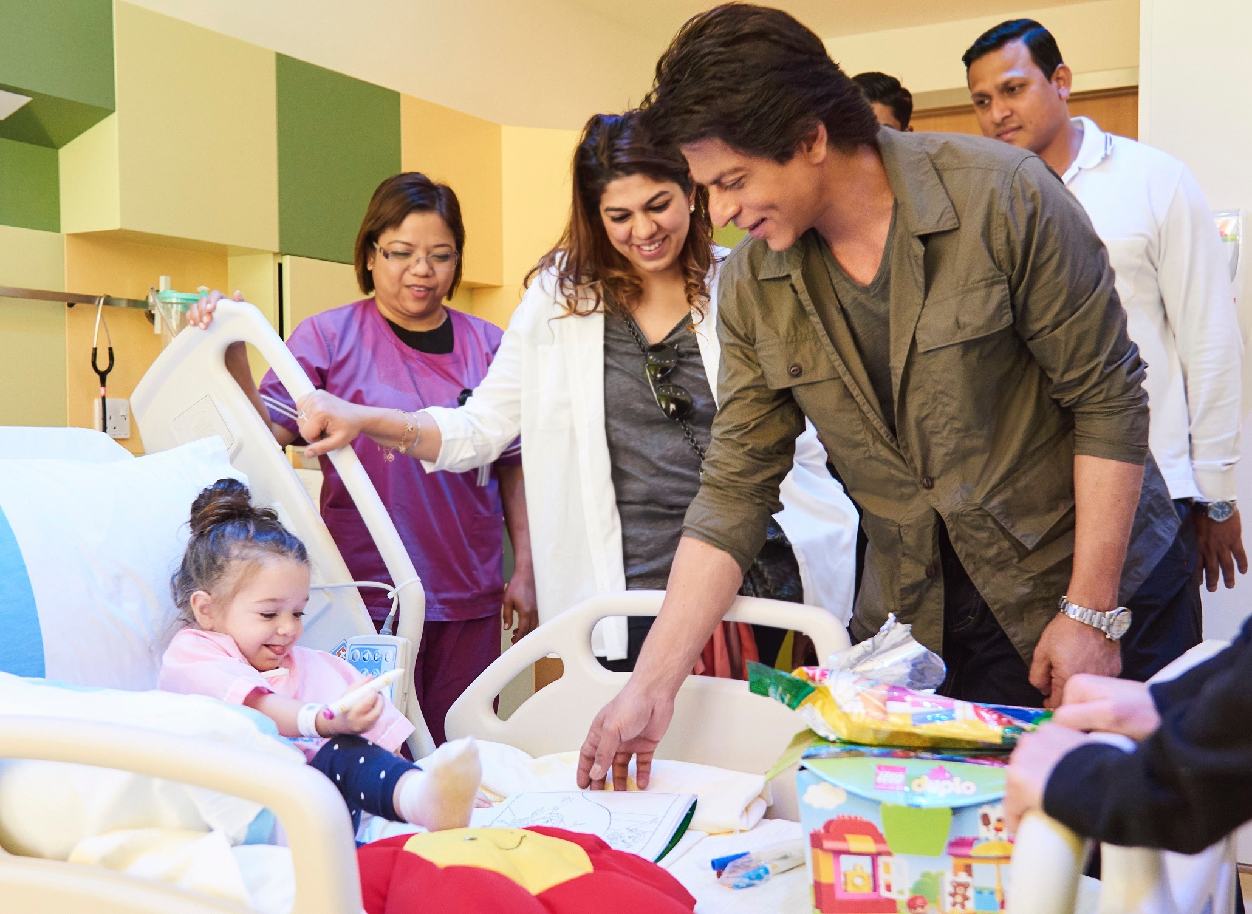
Al Jalila Children’s was established under the directives of His Highness Sheikh Mohammed Bin Rashid Al Maktoum, UAE Vice-President and Prime Minister and Ruler of Dubai, and is the first dedicated children’s hospital in the UAE, providing compassionate and quality healthcare children. His Highness’ vision is to have Al Jalila Children’s as one of the top 10 paediatric hospitals in the world.

Shah Rukh Khan is currently in Dubai filming the sequel to the hugely successful, award-winning #BeMyGuest film, which is part of a promotional campaign run by Dubai Tourism. The original film has so far garnered 45 million views across multiple social media channels as well as 65 million engagements from around the world. #BeMyGuest also reached No.3 on YouTube’s worldwide trending list within 48 hours of its launch, becoming one of the top 10 most viewed videos on the website globally in December.
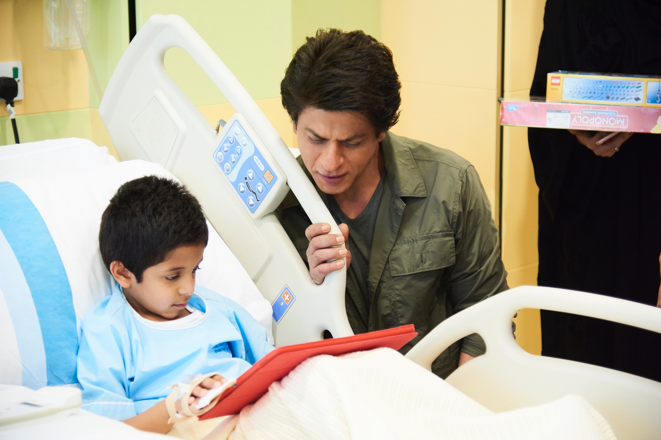
- Ends -

About Dubai’s Department of Tourism and Commerce Marketing (Dubai Tourism)
With the ultimate vision of positioning Dubai as the world’s leading tourism destination and commercial hub, Dubai Tourism’s mission is to increase the awareness of Dubai among global audiences and to attract tourists and inward investment into the emirate.

Dubai Tourism is the principal authority for the planning, supervision, development and marketing of Dubai’s tourism sector. It markets and promotes the Emirate’s commerce sector, and is responsible for the licensing and classification of all tourism services, including hotels, tour operators and travel agents. Brands and departments within the Dubai Tourism portfolio include Dubai Business Events, Dubai Calendar, and Dubai Festivals and Retail Establishment.

For further information, please contact:
Dubai Tourism
mediarelations@dubaitourism.ae
[+971] 600 55 5559
[+971] 4 201 7631

