Press Release

Dubai TOURISM’s #bemyguest FILM STARRING shah rukh khan WINS GRAND PRIX AWARD
at INTERNATIONal tourism film festival

Film also wins first prize in ‘Tourism Destination’ category

Dubai, UAE: 4 May 2017: #BeMyGuest, a promotional film produced by Dubai’s Department of Tourism and Commerce Marketing (Dubai Tourism) starring Bollywood superstar Shah Rukh Khan, has won two top awards at the 10th anniversary of the International Tourism Film Festival, “Tourfilm Riga”, held in Riga, Latvia.

#BeMyGuest won the main award, the Grand Prix, as well as first prize in the ‘Tourism Destination’ category at the festival held on 29 April. Organised by the Riga City Council of Latvia, the event is represented in the prestigious International Committee of the Tourism Film Festivals (CIFFT) and is dedicated to films promoting tourism destinations across the globe.

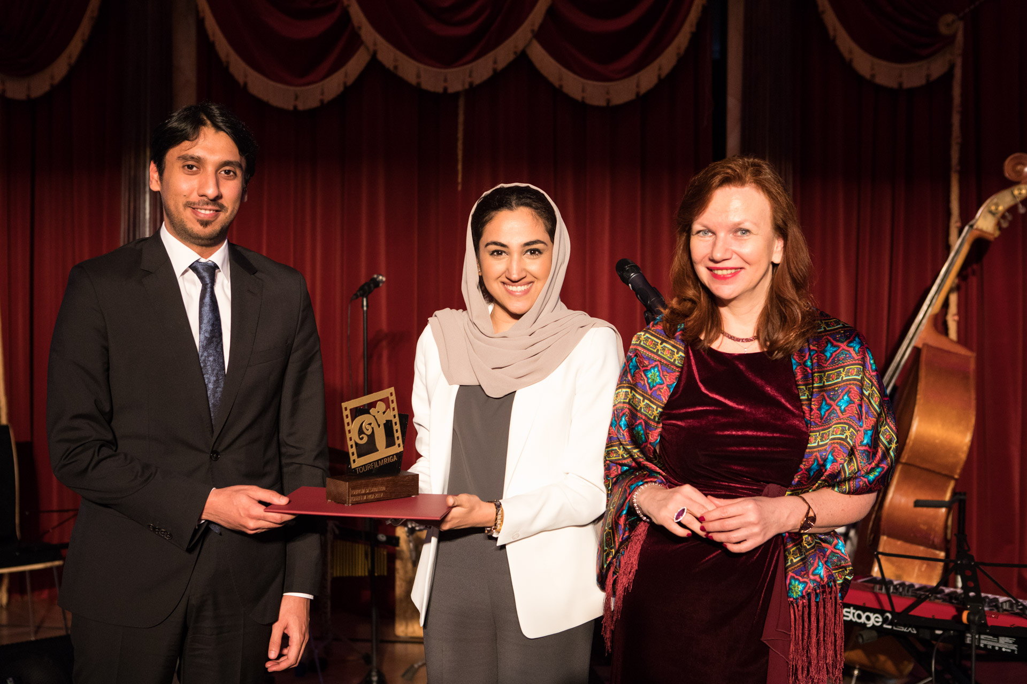
This is the second time in 2017 that #BeMyGuest has been recognised for its artistic merit. In March, the film won the Diamond Award in the ‘City’ category of ITB Berlin’s “Golden City Gate” awards, the world’s premiere film, print and multimedia competition focused on tourism.

#BeMyGuest sees Shah Rukh Khan showcase Dubai’s many attractions, bringing to life the most welcoming aspects of a city that he considers his home away from home. Since its launch in December 2016, #BeMyGuest has garnered 45 million views across multiple social media channels and 65 million engagements from around the world. #BeMyGuest also reached No.3 on YouTube’s worldwide trending list within 48 hours of its launch and became one of the top 10 most viewed videos on the website globally in December.

- Ends –

PHOTO CAPTION
Ahlam AbdulMajeed Bolooki, Senior Manager Campaigns, Campaign Management, Dubai Tourism, who received the award on behalf of Dubai Tourism, is pictured here at the event along with Mr. Yousof Naser AlMazrouei, Charge d'Affaires at the UAE Embassy in Latvia.

About Dubai’s Department of Tourism and Commerce Marketing (Dubai Tourism)
With the ultimate vision of positioning Dubai as the world’s leading tourism destination and commercial hub, Dubai Tourism’s mission is to increase the awareness of Dubai among global audiences and to attract tourists and inward investment into the emirate.

Dubai Tourism is the principal authority for the planning, supervision, development and marketing of Dubai’s tourism sector. It markets and promotes the Emirate’s commerce sector, and is responsible for the licensing and classification of all tourism services, including hotels, tour operators and travel agents. Brands and departments within the Dubai Tourism portfolio include Dubai Business Events, Dubai Calendar, and Dubai Festivals and Retail Establishment.

For further information, please contact:
Dubai Tourism
mediarelations@dubaitourism.ae
[+971] 600 55 5559
[+971] 4 201 7631

