PRESS RELEASE

Dubai brings strong business events presence
to IMEX 2017
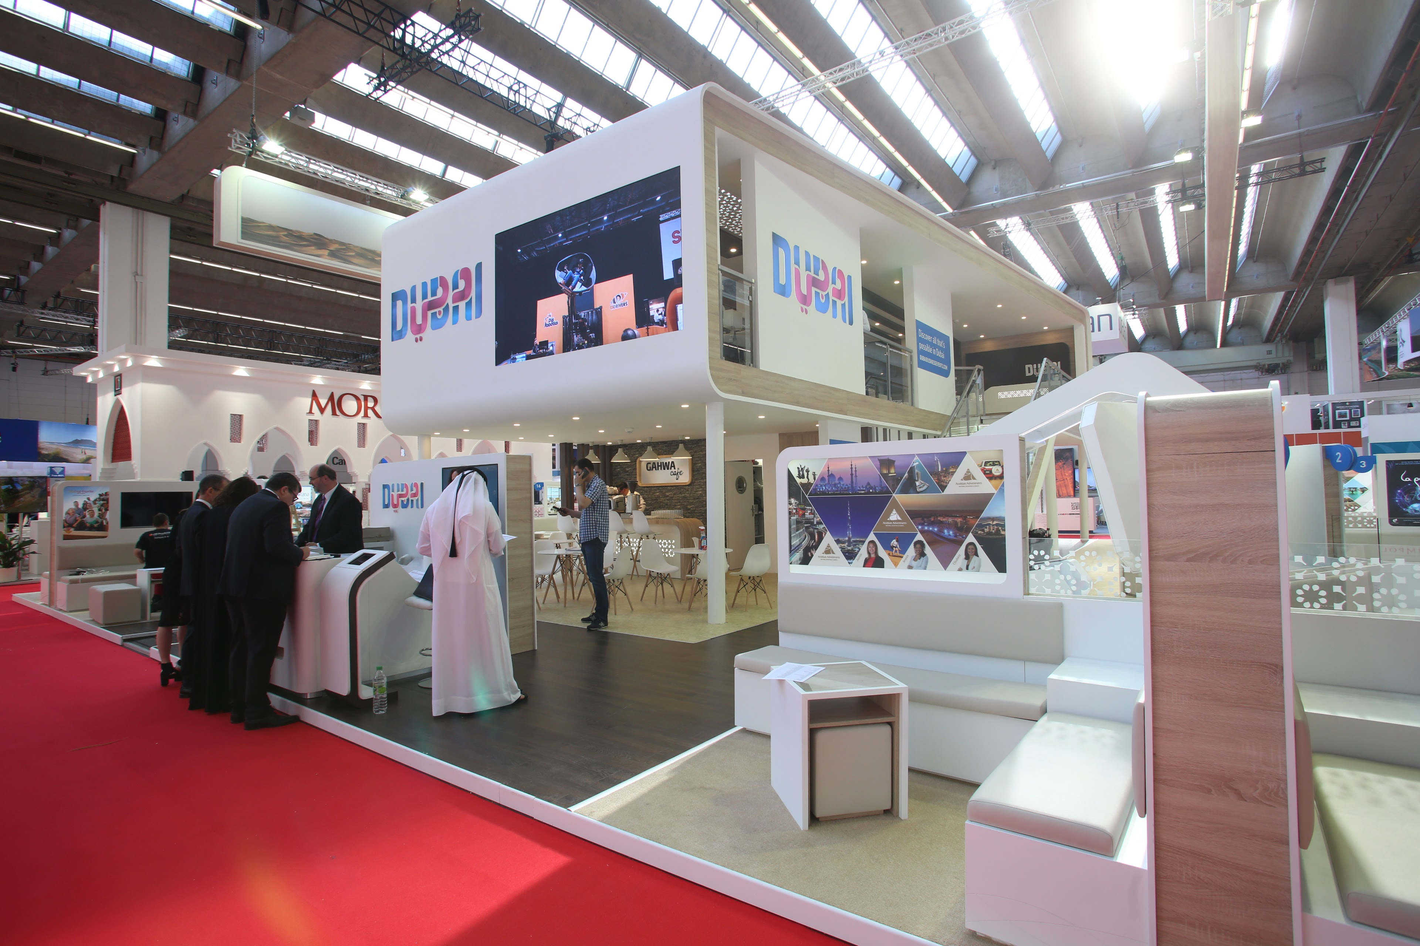
Dubai Business Events and 27 industry stakeholders from across the city have been at the major global events industry exhibition in Frankfurt
Dubai, United Arab Emirates, 18 May 2017: Dubai Business Events (DBE), the city’s official convention bureau and a division of Dubai Corporation for Tourism and Commerce Marketing (DCTCM), has been showcasing Dubai’s dynamic business events offering at IMEX, which has been taking place this week in Frankfurt.
DBE has brought a total of 27 stakeholders and partners to the global events industry exhibition, which has been running 16-18 May, including Emirates, Dubai World Trade Centre and Jumeirah Hotels. Expo 2020 Dubai has been co-exhibiting with DBE for the first time, introducing planners to the mega-event and explaining the opportunities it will afford them. Along with its co-exhibitors, DBE has been showcasing significant developments in Dubai’s business events offerings, further reinforcing the city’s status as a major business events destination. Emphasis also remains on the growing role that business events are playing in transforming Dubai into a global knowledge hub, as well as the emirate’s state-of-the-art facilities, world-class infrastructure and renowned hospitality sector that support the industry.
Issam Kazim, Chief Executive Officer, Dubai Corporation for Tourism and Commerce Marketing, said: “Dubai continues to evolve, both from a leisure and business perspective, and as the city progresses towards a knowledge-based economy, the business events industry is playing a crucial role. Through DBE’s activities during IMEX in Frankfurt, we are aiming to create abundant opportunities for our stakeholders to communicate and do business with industry players from around the globe.”
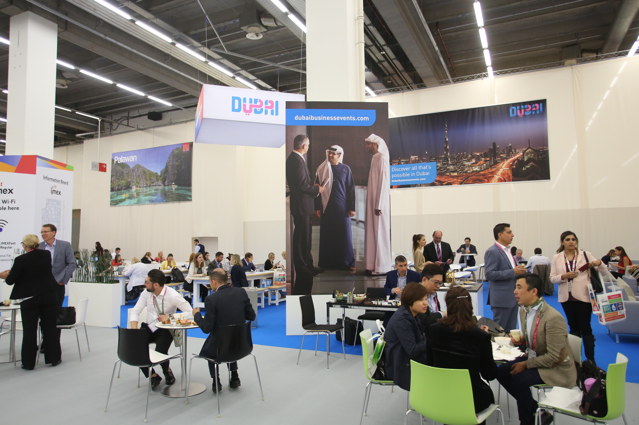

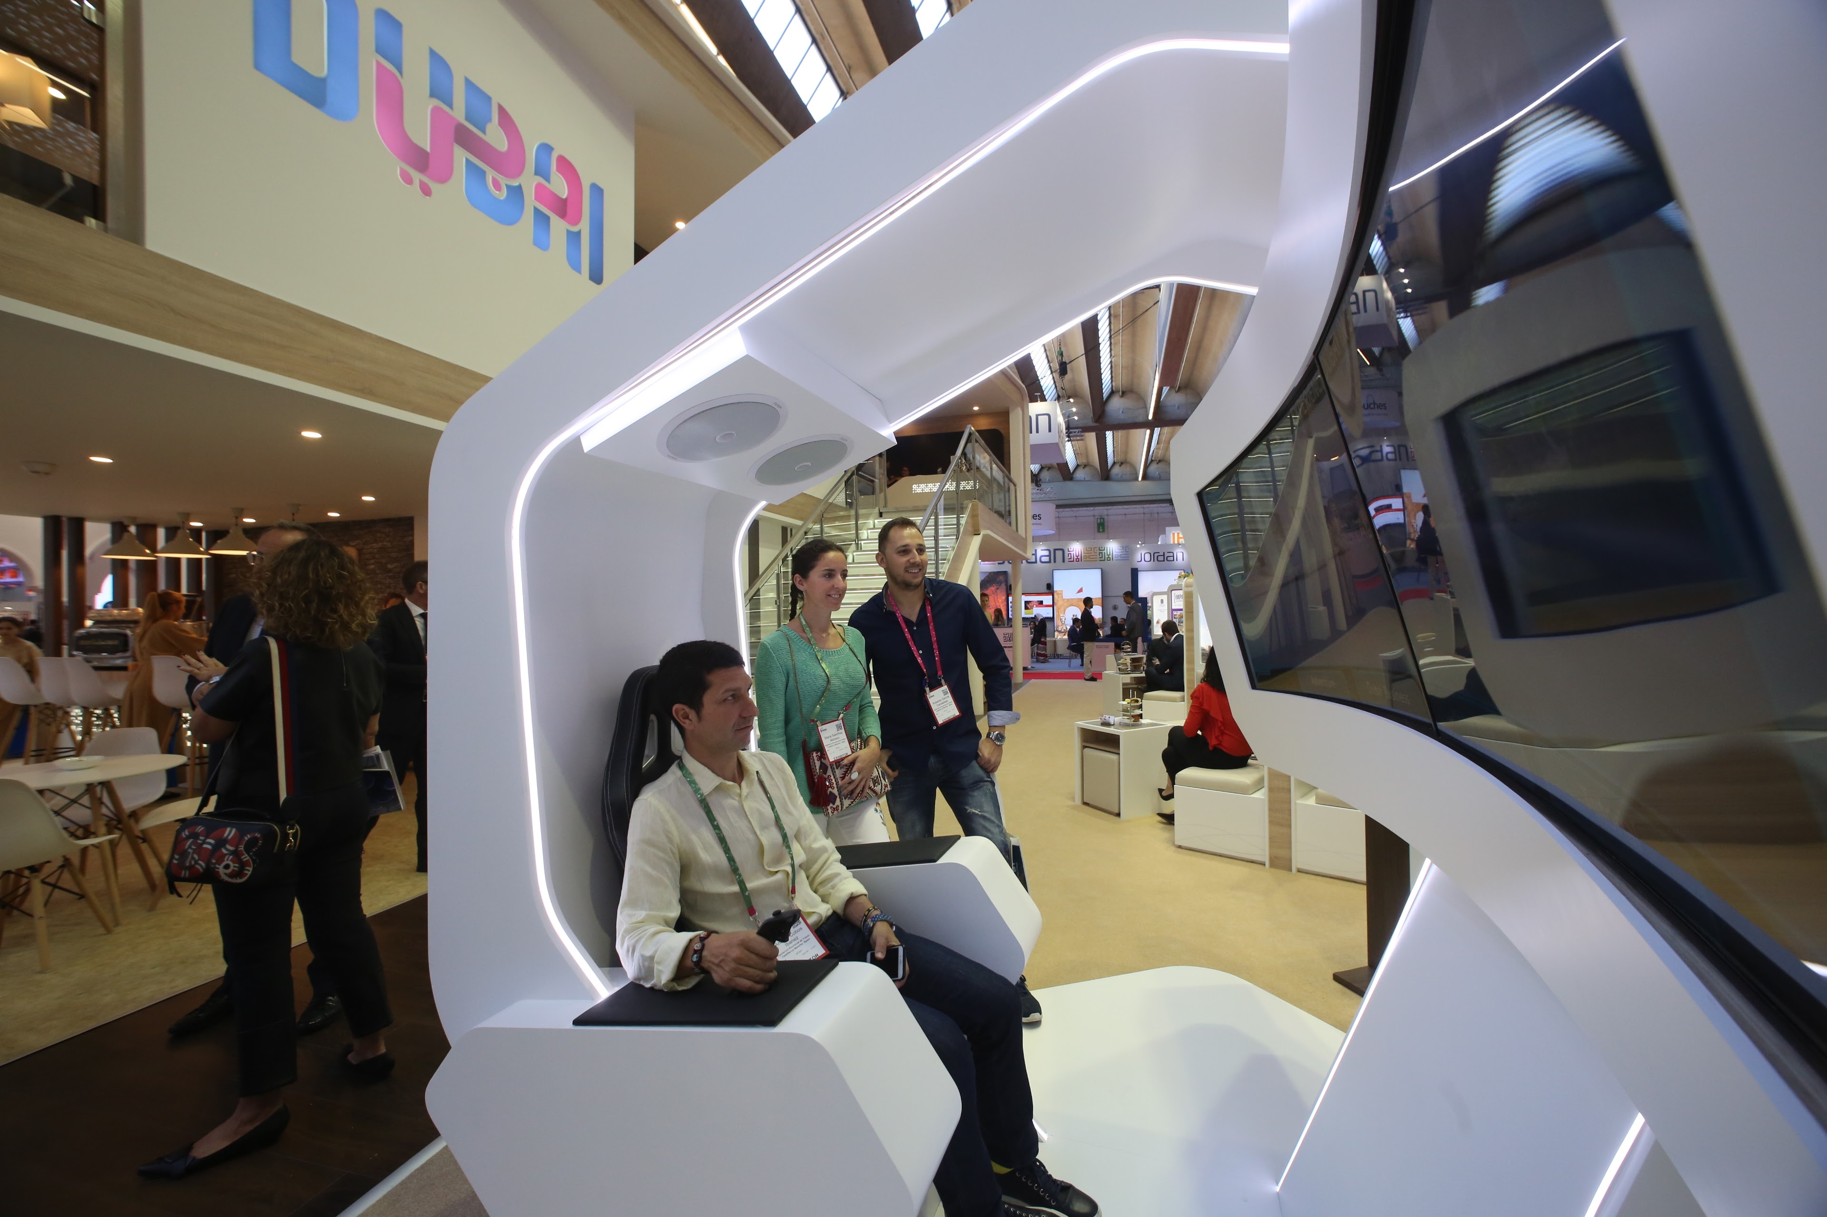

-ENDS-

NOTES TO EDITORS

About Dubai Business Events – the Official Convention Bureau
Dubai Business Events (DBE) – the Official Convention Bureau, aims to further develop and increase Dubai's share of the international business events market in order to grow economic development, jobs and knowledge creation in the emirate. DBE’s main goal, as a division of Dubai Tourism, is to establish the Emirate as a premier business event destination by helping organizers of international meetings, incentives, congresses and exhibitions plan and manage every aspect of their event. As a member of BestCities Global Alliance DBE aim to deliver the world's best service experience for the meeting industry.

About Dubai’s Department of Tourism and Commerce Marketing (Dubai Tourism)
With the ultimate vision of positioning Dubai as the world’s leading tourism destination and commercial hub, Dubai Tourism’s mission is to increase the awareness of Dubai among global audiences and to attract tourists and inward investment into the emirate.

Dubai Tourism is the principal authority for the planning, supervision, development and marketing of Dubai’s tourism sector. It markets and promotes the Emirate’s commerce sector, and is responsible for the licensing and classification of all tourism services, including hotels, tour operators and travel agents. Brands and departments within the Dubai Tourism portfolio include Dubai Business Events, Dubai Calendar, and Dubai Festivals and Retail Establishment.

For further information about DTCM, please contact:
Dubai Tourism
mediarelations@dubaitourism.ae
[+971] 600 55 5559
[+971] 4 201 0491

