Press Release

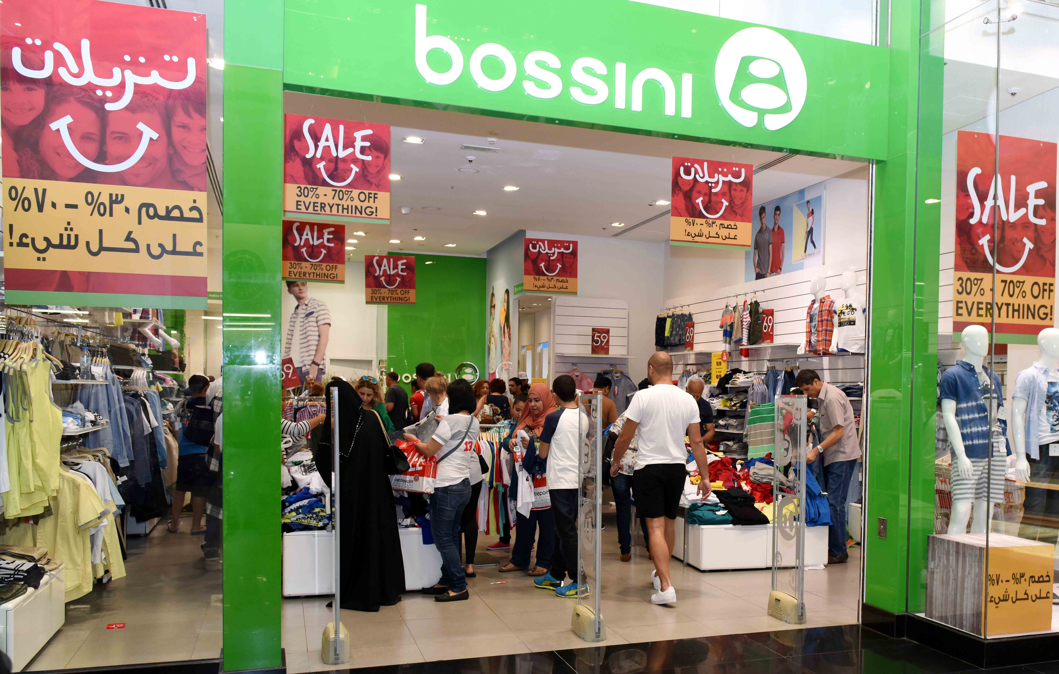
Shoppers throng retail outlets in Dubai’s 3-Day Super Sale
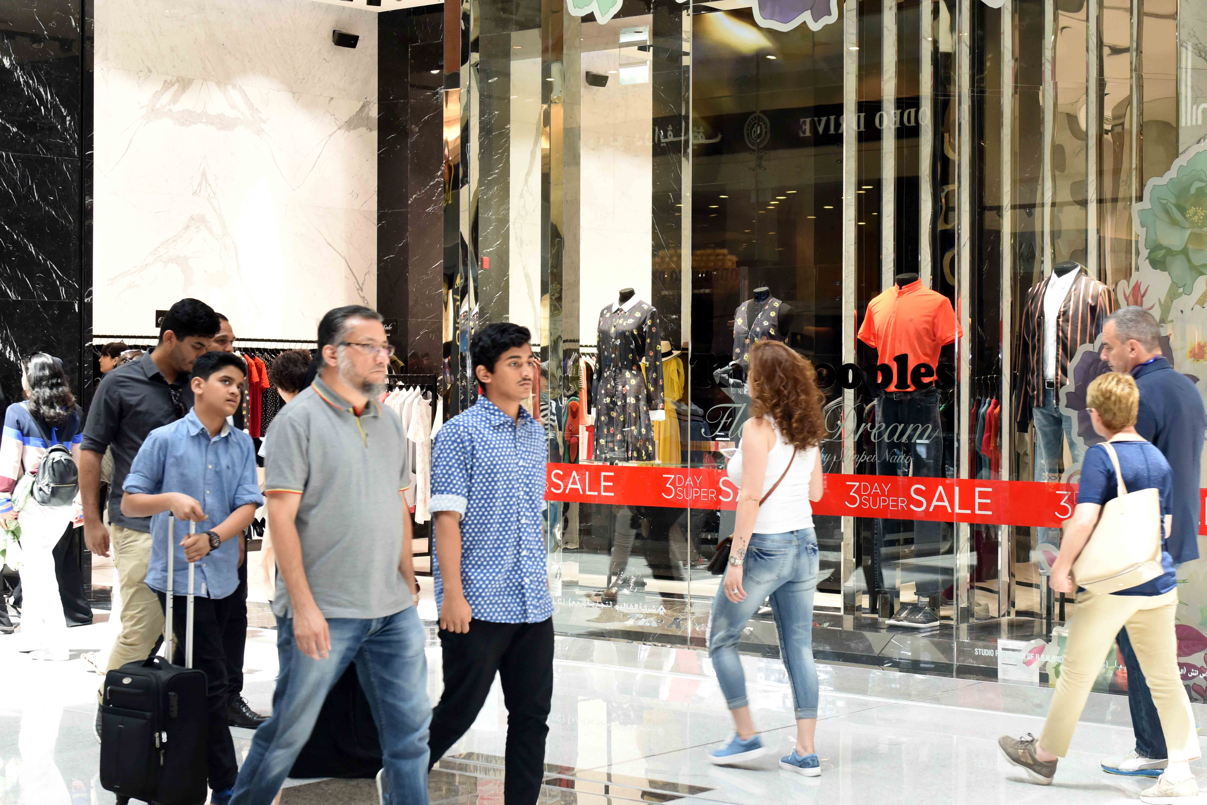
Dubai, UAE, 18 May 2017: Dubai’s new retail promotion, the 3-Day Super Sale started on 18 May with over 1,000 participating retail outlets offering shoppers a rewarding experience with amazing discounts of 30 – 90 % on an extensive range of items from over 250 top brands.

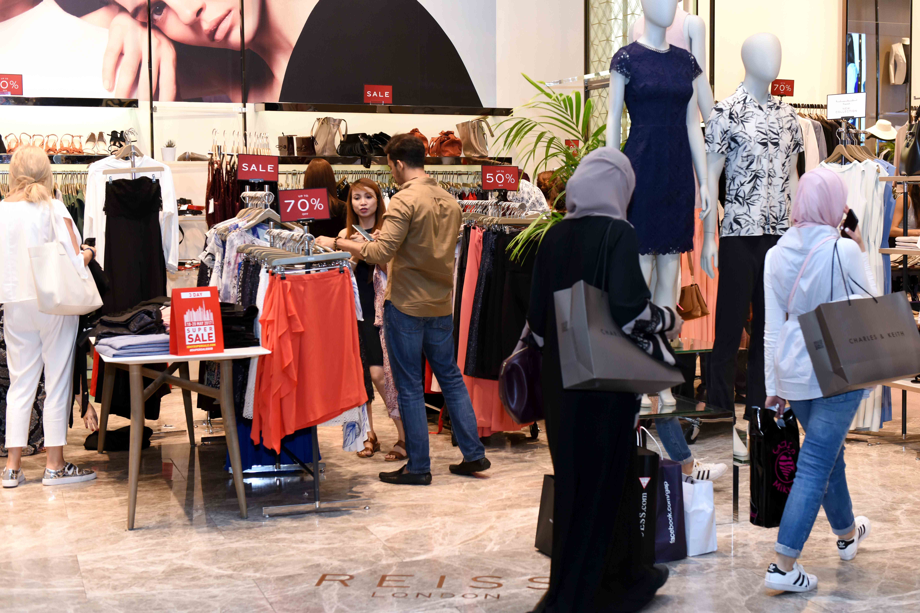
Residents and visitors turned out in large numbers at retail outlets across the city to take advantage of the special deals offered by leading brands on apparel, bags, shoes, cosmetics, perfumes, fashion accessories, home furniture, and much more.

Shopaholics only have until 20 May to pick up unbeatable discounts from the participating brands including Aldo, Al Jaber Optical, Bossini, Carpisa, Crate & Barrel, Charles & Keith, Desigual, Ecco, Galeries La Fayette, Giordano, Guess, Jimmy Choo, Harvey Nichols, Bloomingdale’s, Kurt Geiger, GAP, Nine West, Okaidi, COACH, Porsche Design, Rivoli, Roberto Cavalli, Shoe Mart, Steve Madden, Think Kitchen, and hundreds more.

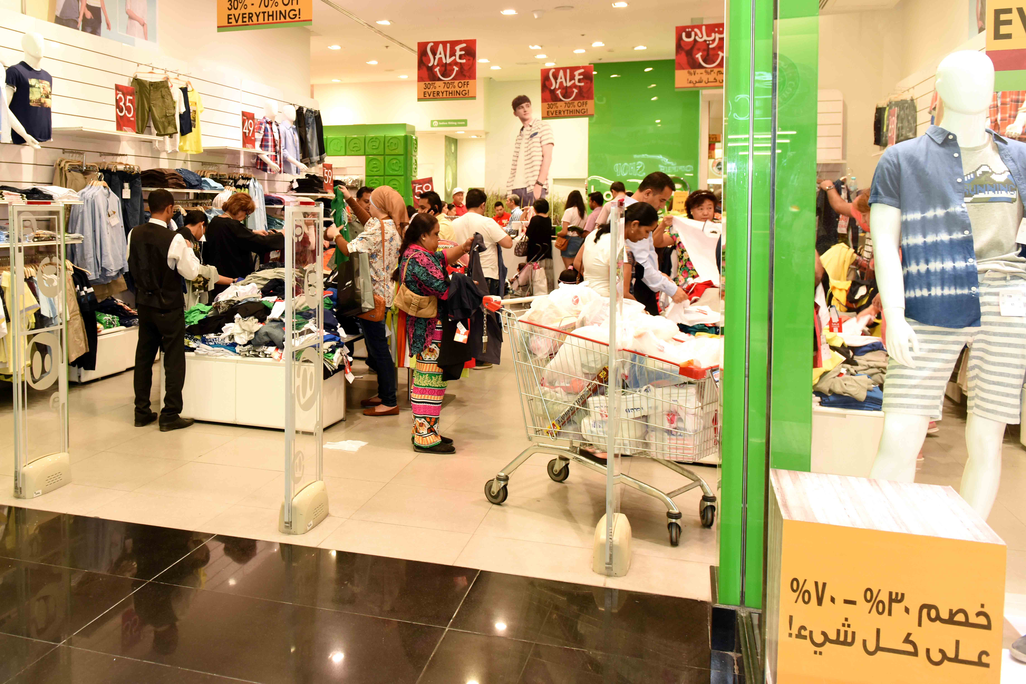
The 3-Day Super Sale is run by the Dubai Festivals and Retail Establishment (DFRE), an agency of the Department of Tourism and Commerce Marketing (Dubai Tourism), and is part of Dubai’s annual Retail Calendar.
For a full list of participating brands, visit www.3daysupersale.com
– Ends –

About Dubai’s Department of Tourism and Commerce Marketing (Dubai Tourism)
With the ultimate vision of positioning Dubai as the world’s leading tourism destination and commercial hub, Dubai Tourism’s mission is to increase the awareness of Dubai among global audiences and to attract tourists and inward investment into the emirate.

Dubai Tourism is the principal authority for the planning, supervision, development and marketing of Dubai’s tourism sector. It markets and promotes the Emirate’s commerce sector, and is responsible for the licensing and classification of all tourism services including hotels, tour operators and travel agents. Brands and departments within the Dubai Tourism portfolio include Dubai Business Events, Dubai Calendar and Dubai Festivals and Retail Establishment.

FOR FURTHER INFORMATION, PLEASE CONTACT:
Dubai Tourism
mediarelations@dubaitourism.ae
[+971] 600 55 5559
[+971] 4 201 7631

