Press Release

dubai to run 3-day Super Sale FROM 18 – 20 MAY
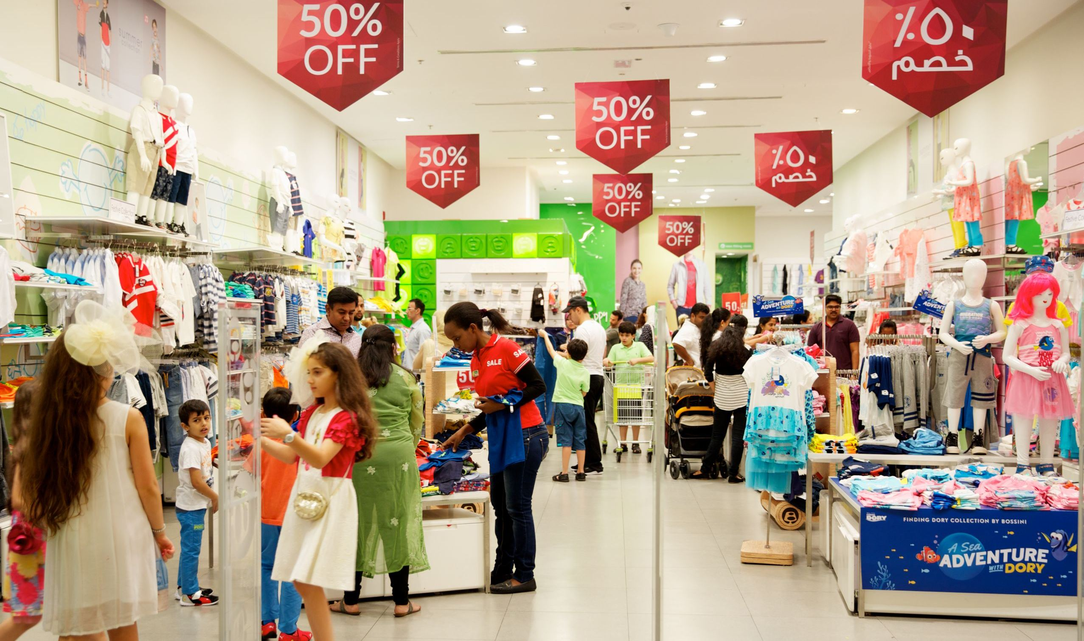
Shoppers in Dubai can get discounts of 30 – 90 % from top brands at citywide retail initiative
Dubai, UAE, 8 May 2017: Retail therapy starts early this summer in Dubai with the 3-day Super Sale, a new citywide retail initiative that will offer shoppers the opportunity to pick up amazing deals across a range of merchandise at participating outlets from 18-20 May.
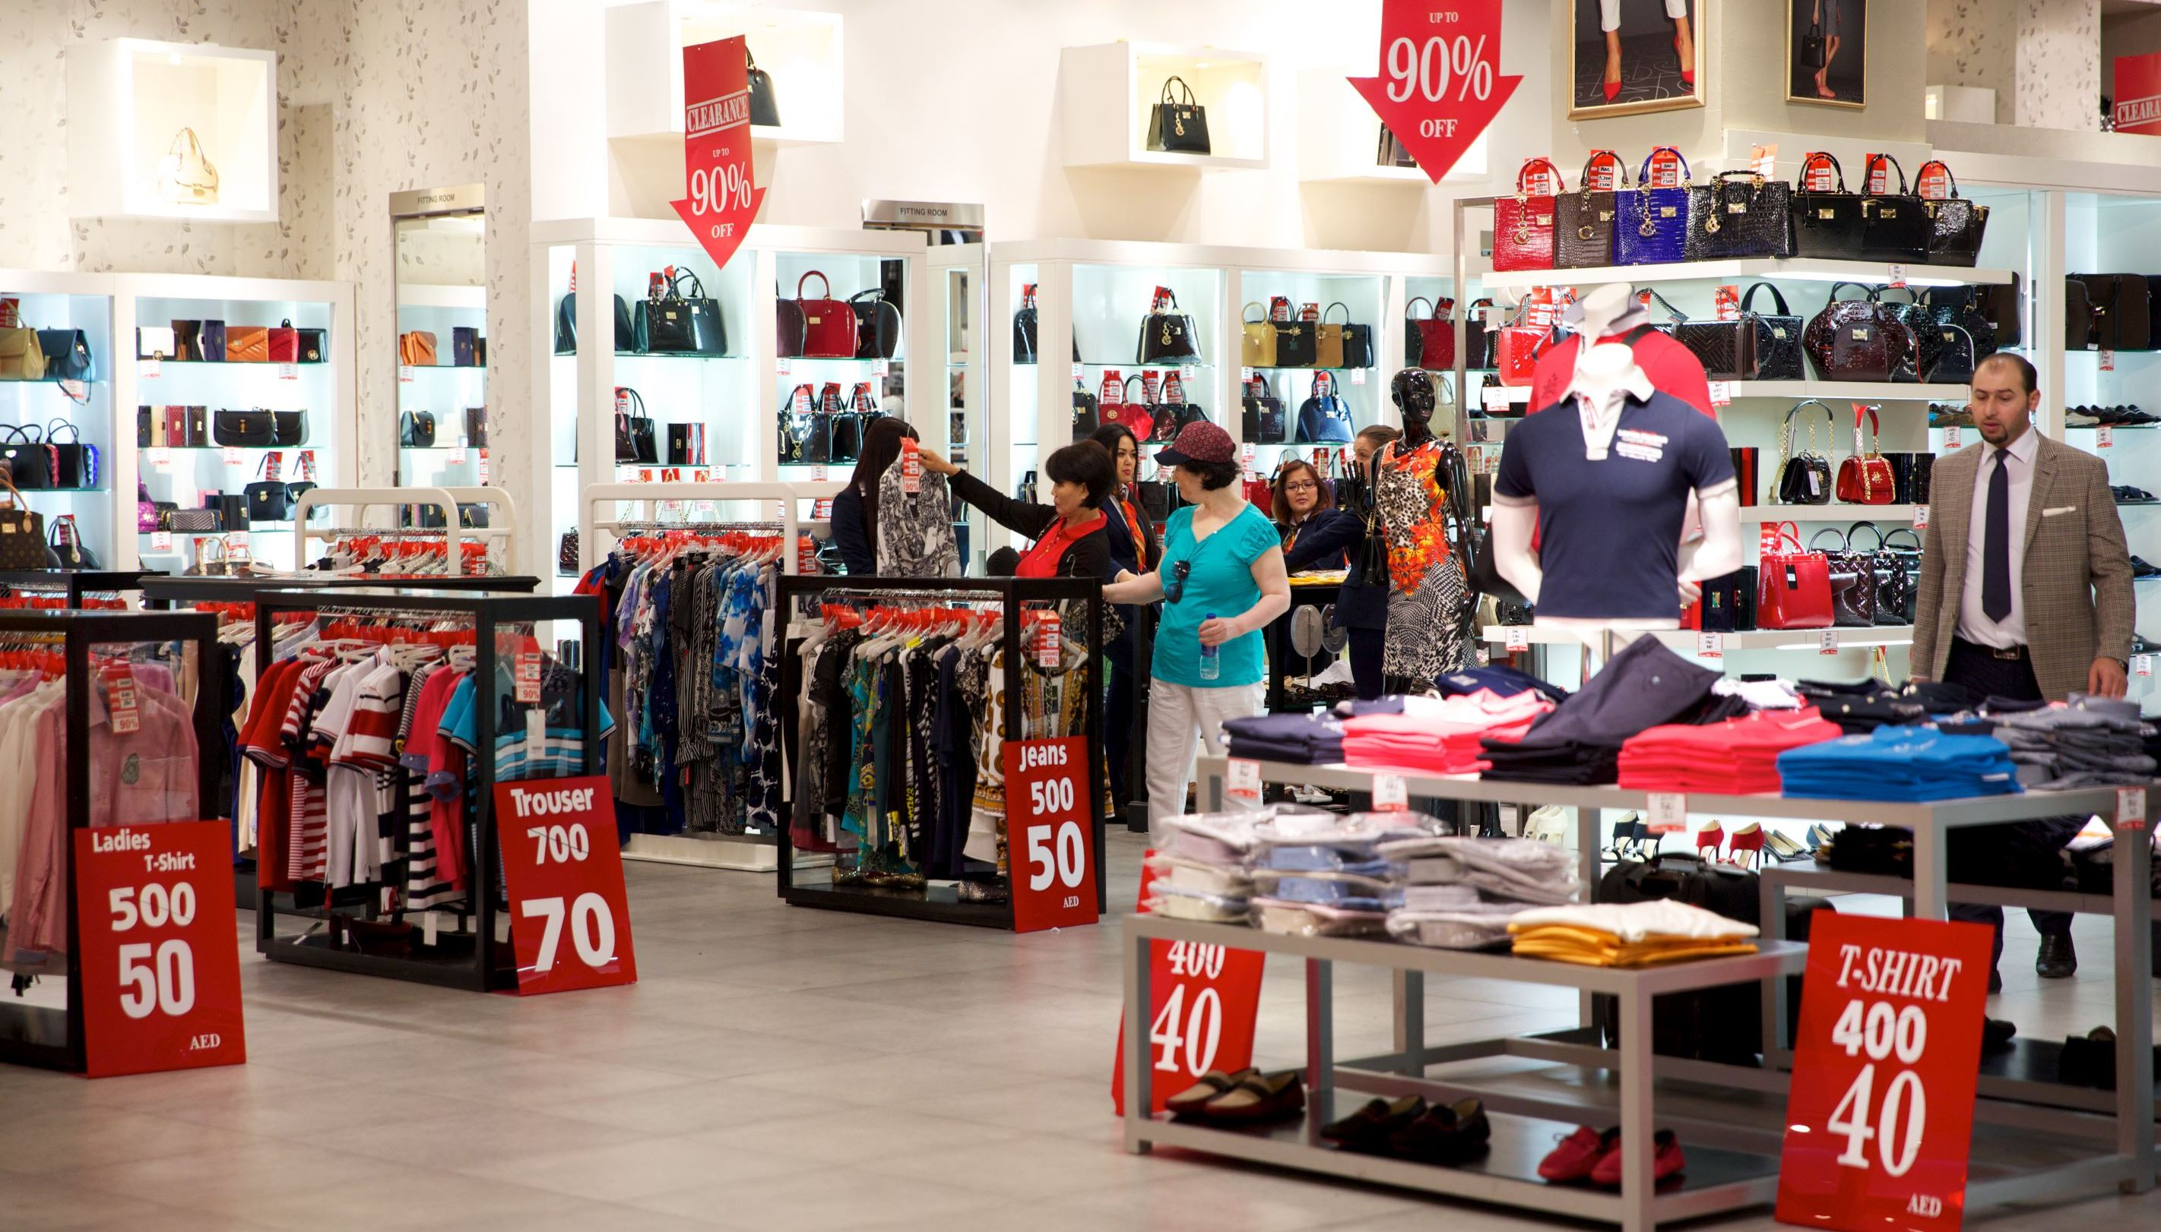
Organised by the Dubai Festivals and Retail Establishment (DFRE), an agency of the Department of Tourism and Commerce Marketing (Dubai Tourism), the 3-day Super Sale will offer shoppers incredible discounts of between 30 – 90 % on selected items at retailers across the city.
Home to some of the world’s most impressive shopping malls and outlets, Dubai is pulling out all the stops for the new retail event with the support of Dubai’s retailers to ensure that shoppers enjoy a rewarding experience across diverse business segments from apparel to electronics, jewellery to fashion accessories, homeware, toys, and much more.
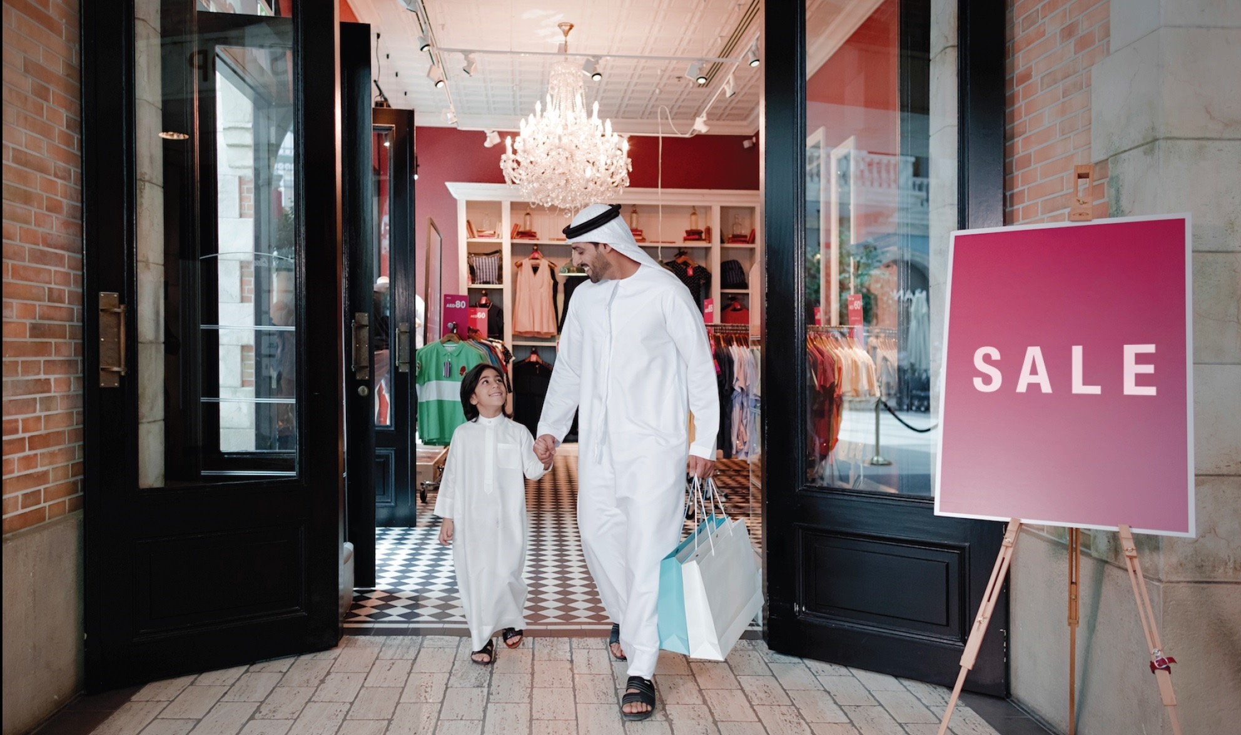
Among the retailers and brands participating in the 3-day Super Sale are Guess, G2000, Bossini, Carpisa, Steve Madden, Kurt Geiger, Kazar, Shoe Mart, Ecco, Roberto Cavalli, Giordano, Galeries La Fayette, Okaidi, Desigual, Aldo, Charles & keith, Call It Spring, Nine West, Rivoli, Hour Choice, La Senza, Think Kitchen, Al Jaber Optical, Porsche Design, Paul & Shark, and hundreds more.
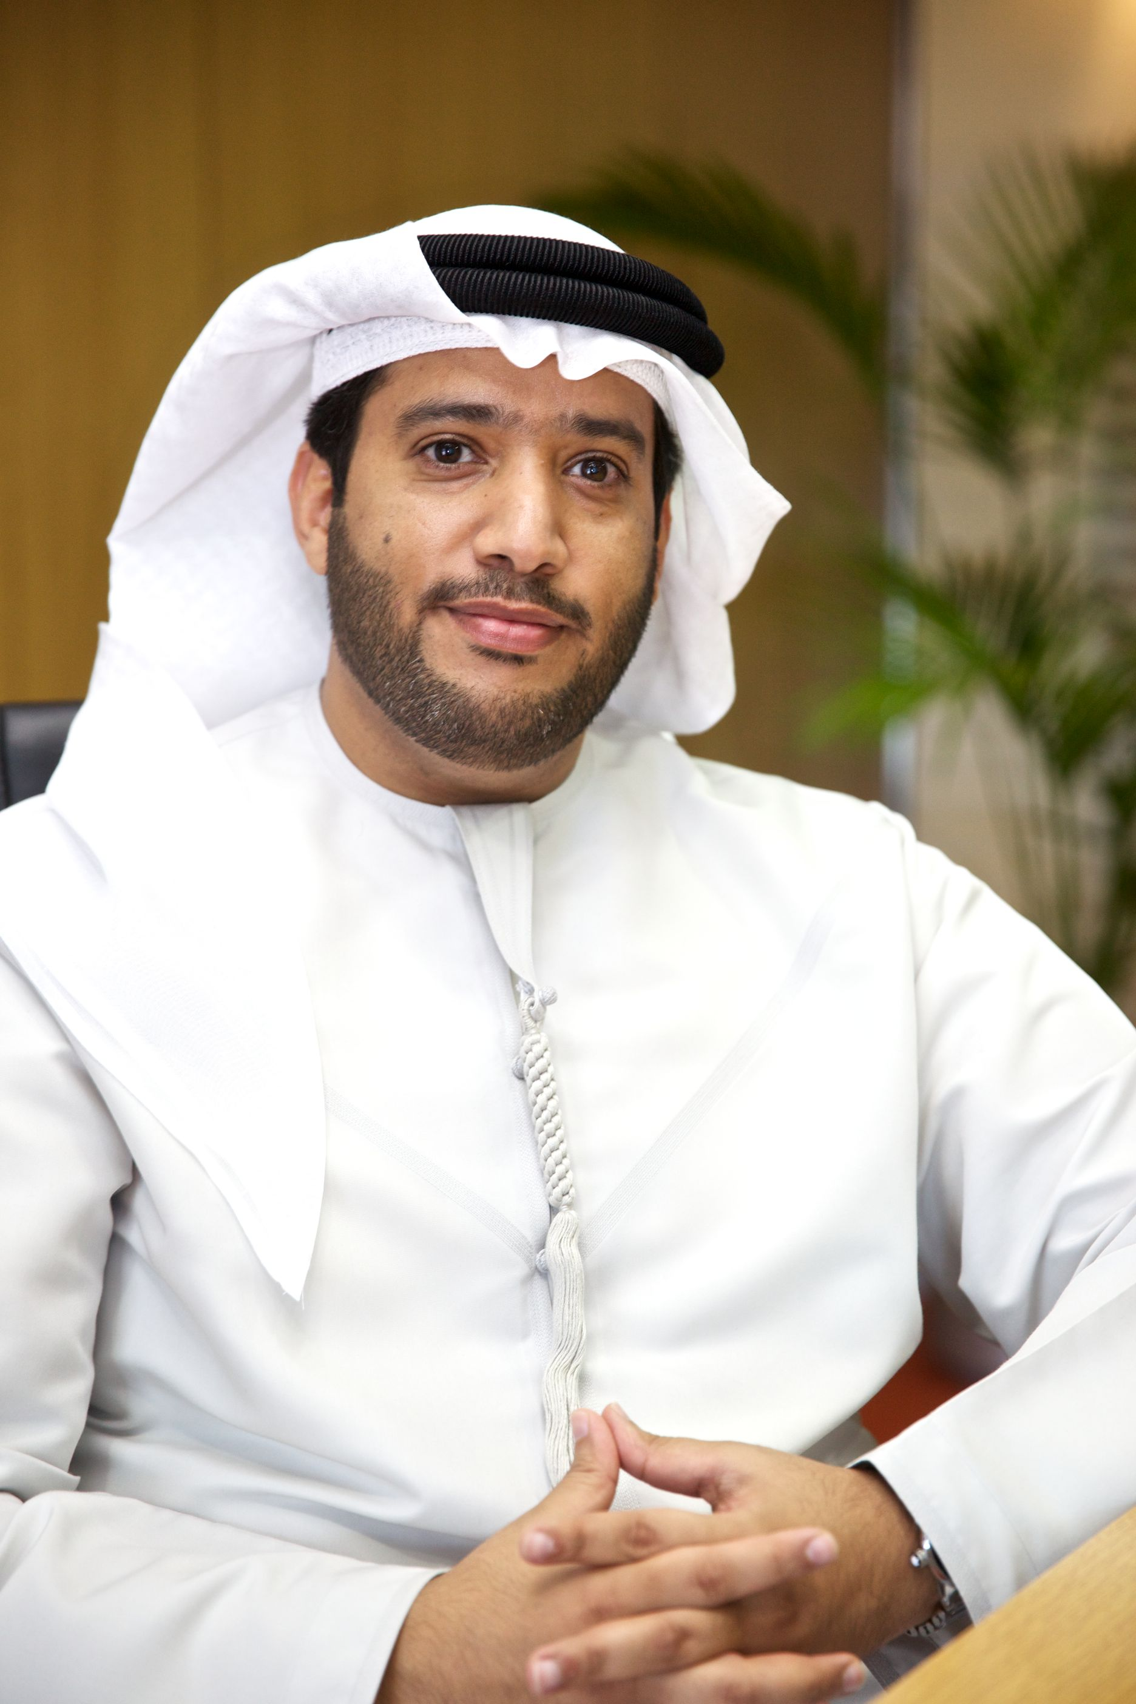
The 3-day Super Sale is part of Dubai’s annual Retail Calendar that features major retail-based festivals, new season launches, mega sales and clearance events, exclusive retail experiences and attractions aimed at further enhancing the retail sector in Dubai.
Saeed Mohammad Measam Al Falasi, Executive Director, Retail and Strategic Alliances, DFRE, said: “The 3-Day Super Sale initiative is part of our robust strategy revolving around the Retail Calendar to further boost the emirate’s retail sector with regular promotional periods that benefit both retailers and shoppers. Running promotions that offer retailers numerous options to boost sales during this time of the year will further enhance the emirate’s appeal as a year-round shopping hub, and helps us build on Dubai’s strong position as only the second city after London to host the most number of retail brands.
“With the help of our partners in the private sector, Dubai has set the highest standards in terms of brand mix and quality in the retail sector in the region, and we are happy to see leading retail groups once again extending a firm hand to ensure the success of this new retail event. The timing is perfect for shoppers, coming early in the summer and just a few days before the start of the month of Ramadan, followed by the Eid holiday period. We expect to reenergise the retail sector at this event, as large number of shoppers are bound to avail themselves of three days of huge savings.”
According to a report by the Dubai Chamber of Commerce and Industry, retailing is forecast to reach Dh200 billion by 2017, growing by 5% on average each year. Consumer spending is also expected to continue rising in the medium-term, with growth rates projected to stabilize at about 4% on average per year leading to a total spending of more than AED 750 billion by 2017 across many segments.
For more information, visit www.3daysupersale.com

– Ends –

About Dubai’s Department of Tourism and Commerce Marketing (Dubai Tourism)
With the ultimate vision of positioning Dubai as the world’s leading tourism destination and commercial hub, Dubai Tourism’s mission is to increase the awareness of Dubai among global audiences and to attract tourists and inward investment into the emirate.

Dubai Tourism is the principal authority for the planning, supervision, development and marketing of Dubai’s tourism sector. It markets and promotes the Emirate’s commerce sector, and is responsible for the licensing and classification of all tourism services including hotels, tour operators and travel agents. Brands and departments within the Dubai Tourism portfolio include Dubai Business Events, Dubai Calendar and Dubai Festivals and Retail Establishment.

FOR FURTHER INFORMATION, PLEASE CONTACT:
Dubai Tourism
mediarelations@dubaitourism.ae
[+971] 600 55 5559
[+971] 4 201 7631

