MEDIA ALERT

20th edition of Dubai Summer Surprises offers
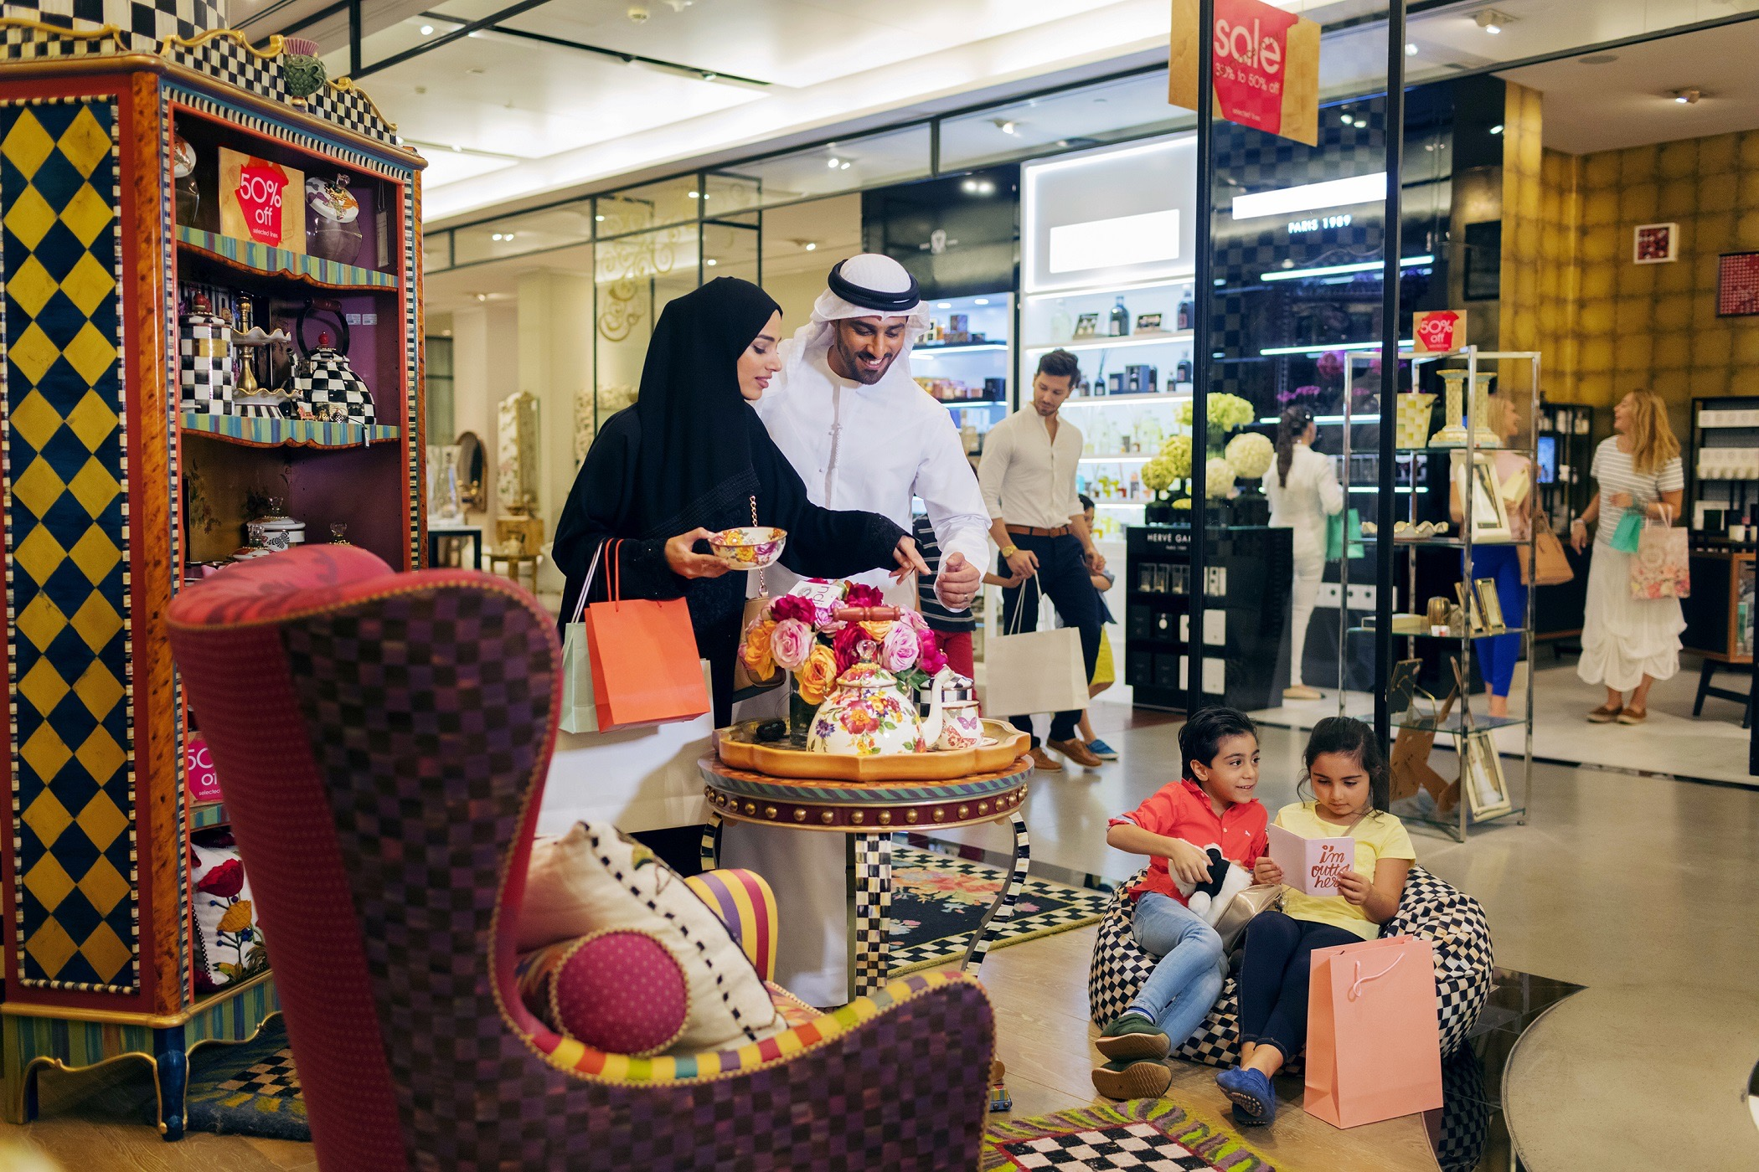
six weeks of sales

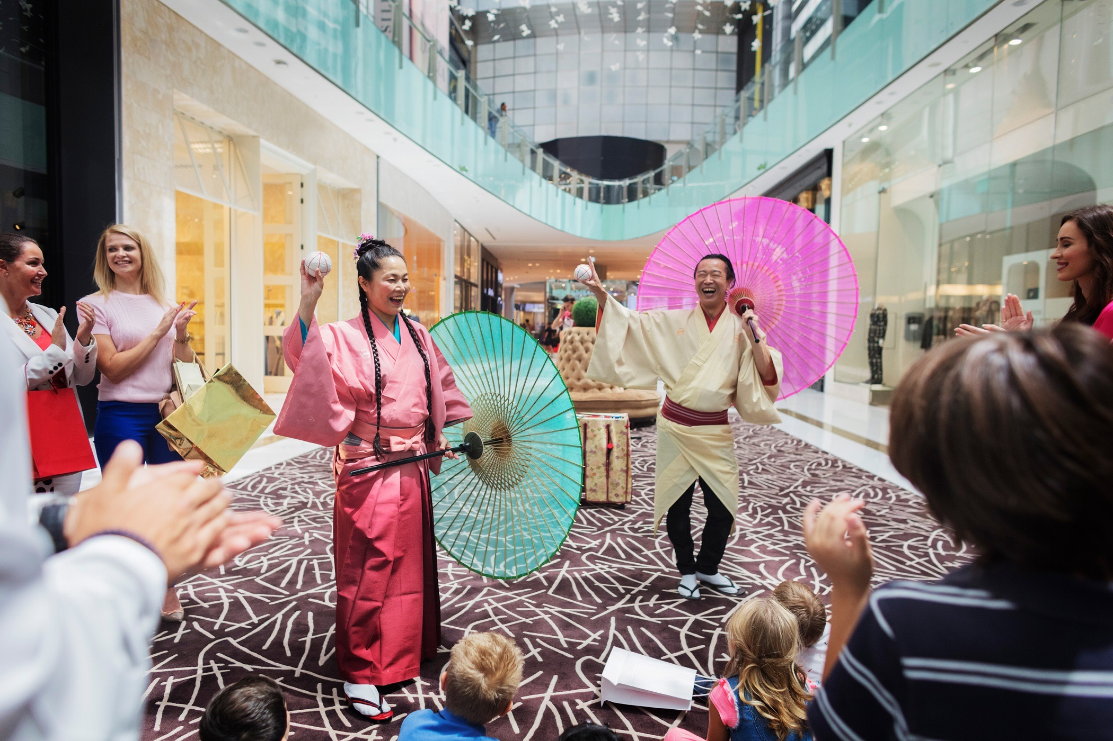
Dubai, UAE 24 May 2017: Dubai Summer Surprises (DSS) is back for a record year from 1 July to 12 August 2017. The 20th edition will offer residents and visitors an exciting six week calendar of sales and family entertainment. Organised by the Dubai Festivals and Retail Establishment (DFRE), an agency of the Department of Tourism and Commerce Marketing (Dubai Tourism), this year’s DSS will run for 43 days under the slogan ‘Enjoy 6 weeks of sales.’

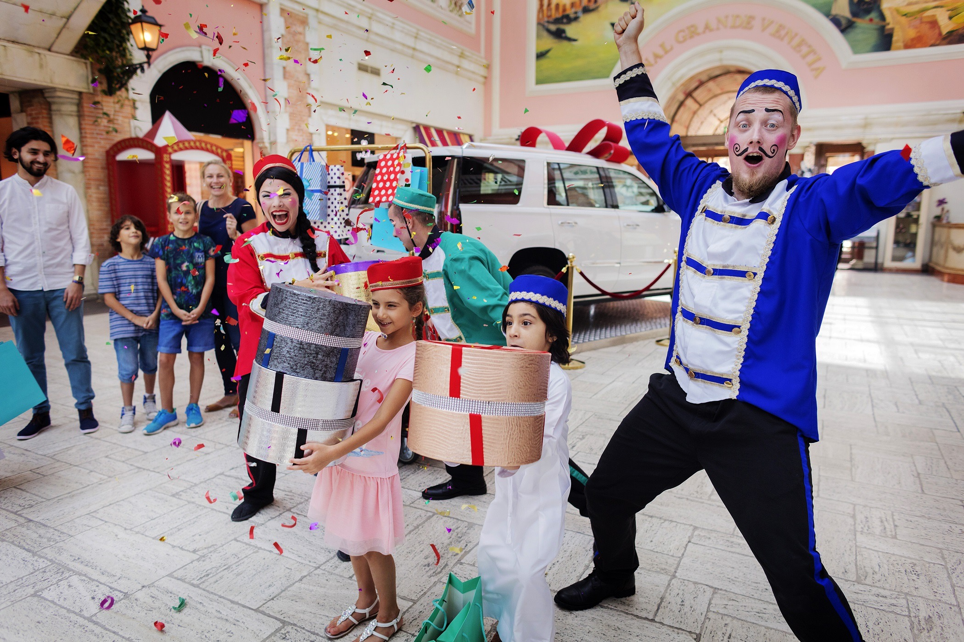
DSS 2017 will feature a series of retail promotions offering the best deals and discounts and the opportunity to win fabulous prizes at malls run in collaboration with the Dubai Shopping Malls Group. Thousands of retail outlets will reward visitors with special offers and discounts of up to 75 per cent on a wide range of merchandise. This year’s DSS is also the time for families to make the most of their summer, with a range of entertainment including Arabic concerts, Modhesh World, the region’s most popular family indoor edutainment centre; and a variety of cartoon character performances and world-class shows (including Transformers, Aladdin, Ghostbusters, Pirates in the Caribbean) taking place at malls across the city.

With a view to attracting as many visitors from around the world, the organisers will launch a marketing campaign in international markets with a focus on digital platforms and social media.

For more information go to: www.dubaisummersurprises.com

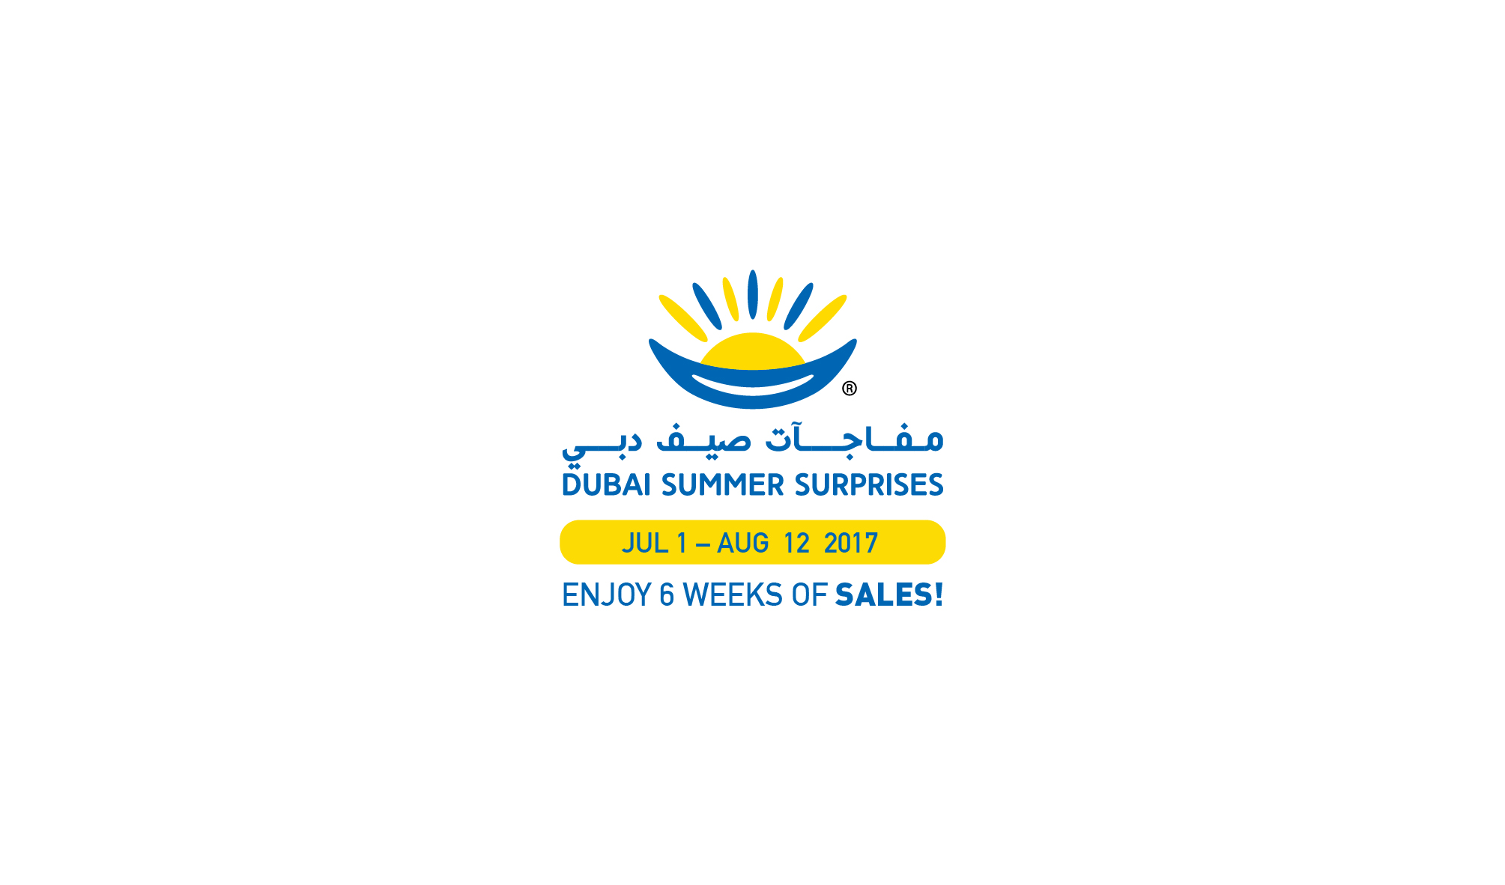

– Ends –

About Dubai’s Department of Tourism and Commerce Marketing (Dubai Tourism)
With the ultimate vision of positioning Dubai as the world’s leading tourism destination and commercial hub, Dubai Tourism’s mission is to increase the awareness of Dubai among global audiences and to attract tourists and inward investment into the emirate.

Dubai Tourism is the principal authority for the planning, supervision, development and marketing of Dubai’s tourism sector. It markets and promotes the Emirate’s commerce sector, and is responsible for the licensing and classification of all tourism services including hotels, tour operators and travel agents. Brands and departments within the Dubai Tourism portfolio include Dubai Business Events, Dubai Calendar and Dubai Festivals and Retail Establishment.

FOR FURTHER INFORMATION, PLEASE CONTACT:
Dubai Tourism
mediarelations@dubaitourism.ae
[+971] 600 55 5559
[+971] 4 201 7631

