Press Release

DUBAI’S 3-DAY SUPER SALE KICKS OFF ON 18 MAY
Over 1,000 retail outlets set to offer mega savings for shoppers with discounts of 30 – 90 %
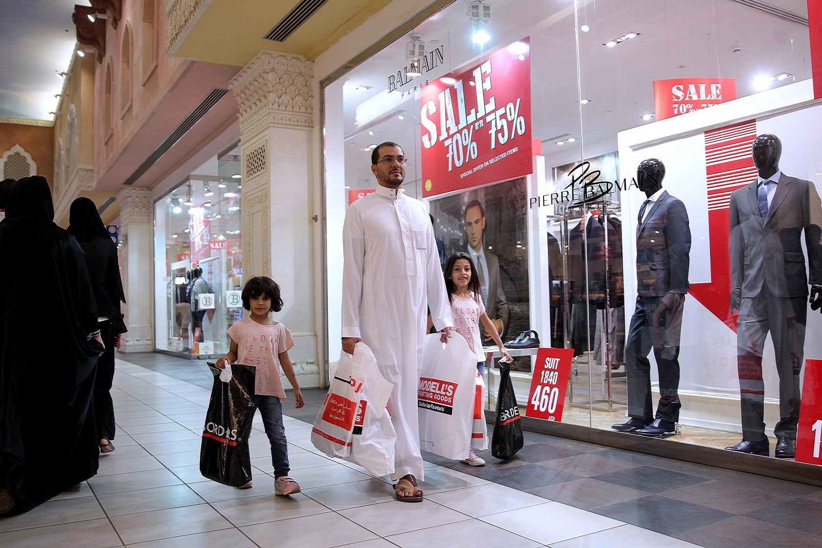

Dubai, UAE, 16 May 2017: Get ready for a rewarding shopping experience in Dubai at the 3-day Super Sale, a new citywide retail initiative, which kicks off on 18 May with over 1,000 outlets offering a diverse range of items from local, regional and global brands, at significantly low prices.
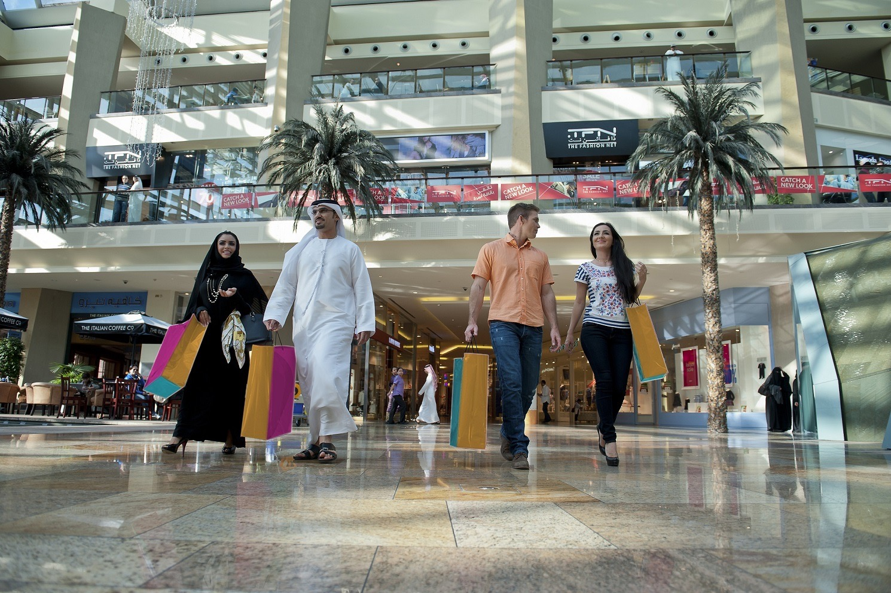

Organised by the Dubai Festivals and Retail Establishment (DFRE), an agency of the Department of Tourism and Commerce Marketing (Dubai Tourism), the 3-day Super Sale will see over 250 brands offering shoppers 30 – 90 % off on an array of merchandise including apparel, bags, shoes, cosmetics, perfumes, fashion accessories and home furniture.

This not-to-be-missed retail promotion running across Dubai offers an extensive range of choices for shoppers preparing for their summer holidays, followed by the Eid holiday period, and is part of efforts to further enhance Dubai’s position as a year-round shopping destination.

Among the participating retailers and brands are Aldo, Al Jaber Optical, Bossini, Carpisa, Crate & Barrel, Charles & keith, Desigual, Ecco, Galeries La Fayette, Giordano, Guess, Jimmy Choo,
Harvey Nichols, Bloomingdale’s, Kurt Geiger, La Fayette, GAP, Nine West, Okaidi, COACH, Porsche Design, Rivoli, Roberto Cavalli, Shoe Mart, Steve Madden, Think Kitchen, and hundreds more.
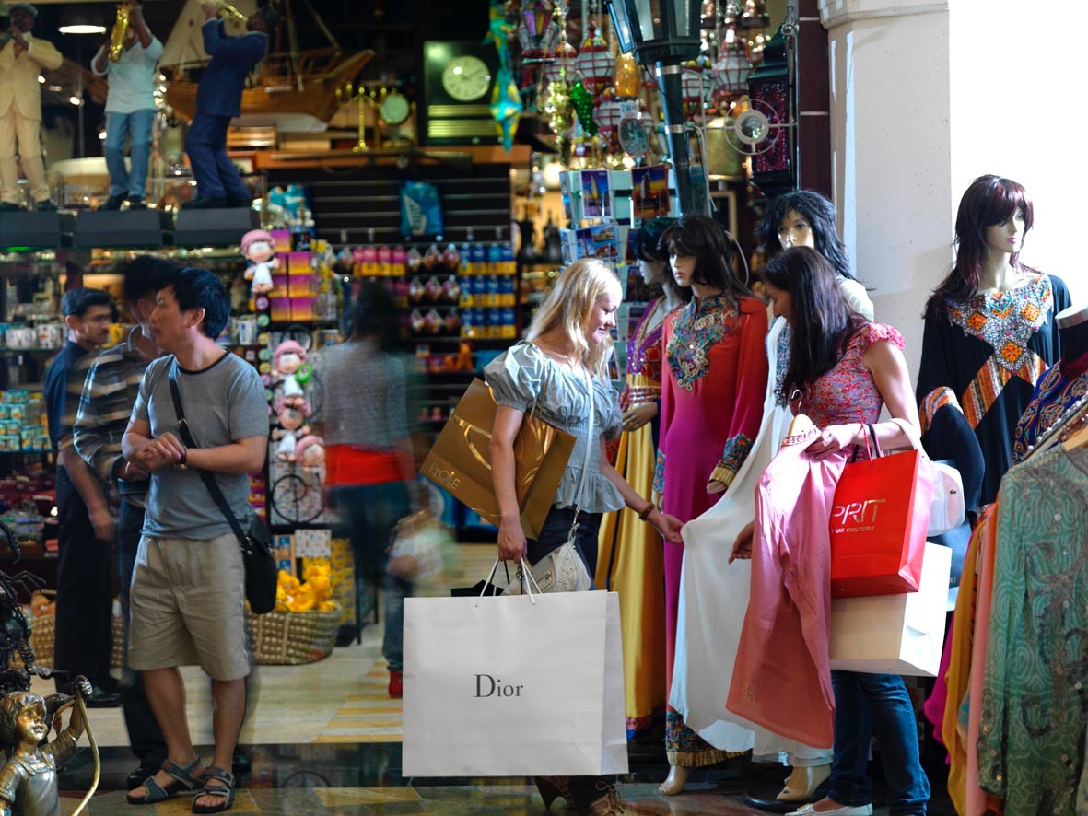
Pick up discounts of up to 90% from fashion and lifestyle brands such as Balmain, Blanco, Disney Fashion, Forever 21, M & Co, La Senza, Louis Feraud and Vero Moda, and from furniture retailers like IDdesign and Marlin Furniture.
The 3-day Super Sale is also part of Dubai’s annual Retail Calendar that features major retail-based festivals, new season launches, mega sales and clearance events, exclusive retail experiences and attractions aimed at further enhancing the retail sector, a main contributor towards Dubai’s economy.

Get ready for a great weekend of shopping and super savings.
For more information, visit www.3daysupersale.com

– Ends –

About Dubai’s Department of Tourism and Commerce Marketing (Dubai Tourism)
With the ultimate vision of positioning Dubai as the world’s leading tourism destination and commercial hub, Dubai Tourism’s mission is to increase the awareness of Dubai among global audiences and to attract tourists and inward investment into the emirate.

Dubai Tourism is the principal authority for the planning, supervision, development and marketing of Dubai’s tourism sector. It markets and promotes the Emirate’s commerce sector, and is responsible for the licensing and classification of all tourism services including hotels, tour operators and travel agents. Brands and departments within the Dubai Tourism portfolio include Dubai Business Events, Dubai Calendar and Dubai Festivals and Retail Establishment.

FOR FURTHER INFORMATION, PLEASE CONTACT:
Dubai Tourism
mediarelations@dubaitourism.ae
[+971] 600 55 5559
[+971] 4 201 7631

