Press Release

Dubai Tourism champions vocational education with the launch of Dubai College of Tourism

College to welcome first batch of students in September 2017

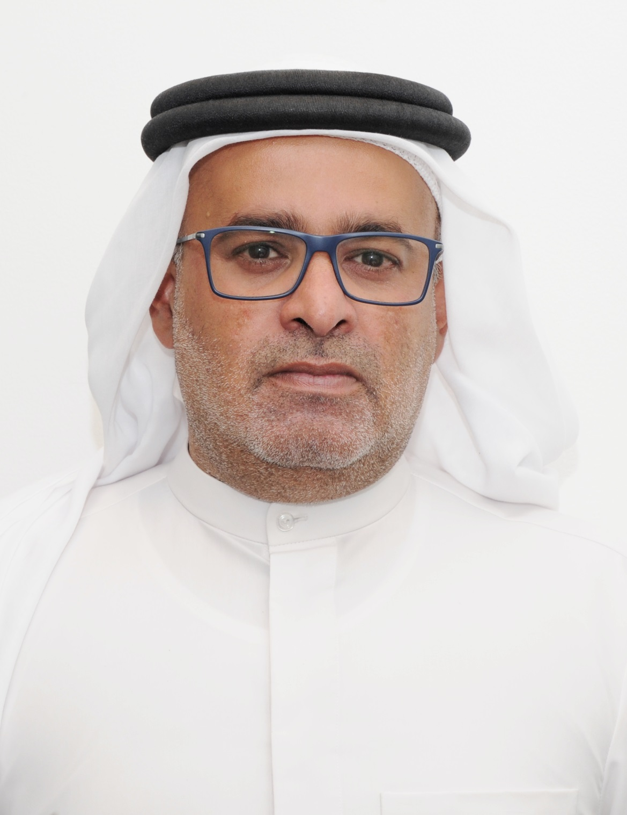

Dubai, UAE: 25 April 2017: Dubai’s Department of Tourism and Commerce Marketing (Dubai Tourism) has announced the launch of Dubai College of Tourism (DCT), an institution dedicated to training the next generation of tourism professionals and providing school leavers with an alternative option for further education, that bridges the gap between in-house training and a full bachelor’s degree. The Government backed vocational college will be accepting its first batch of students in September 2017.

DCT’s mandate is to educate and empower future leaders, entrepreneurs and employees of Dubai’s expanding tourism industry, ensuring a steady pipeline of highly trained hospitality professionals for the city. The opening of the institution is in line with Dubai Tourism’s strategy, that aims to welcome 20 million visitors to the city by 2020. In addition, the college will also serve as the base to develop and roll out training and industry on-boarding programmes that encourage young UAE Nationals to be part of the city’s evolving tourism sector.

Furthermore, DCT’s focus on vocational led education, addresses the need to increase the number of technical education options across the emirate, to help students specialise in a specific trade. According to a 2014 Deloitte study, only one to three per cent of Dubai’s students enroll in vocational education after high school which could lead to labour shortages within key industries in the future. With Dubai’s tourism sector set to employ a workforce of more than half a million by 2020, dedicated vocational training for the industry has never been more important.

DCT’s practical and flexible vocational courses are focused around five core faculties - Tourism, Events, Hospitality, Retail and Culinary Arts - and have been designed to help young people learn various trade and soft skills from established professionals in the industry. Plus, the ‘job-focused’ training on offer will be attractive for students who do not want to continue with ‘academic’ study and provides a clear path to a myriad of exciting and rewarding career opportunities within Dubai’s tourism and hospitality sectors.

The college’s educational programmes will be accredited by Dubai’s Knowledge and Human Development Authority (KHDA), and DCT has also partnered with Australian vocational educational experts TAFE SA, whose advisors will be providing curriculum development support and teacher training expertise. Additionally, the college has put in place an ‘Advisory Board’ of key stakeholders within Dubai’s tourism sector, to ensure that the courses offered are of the upmost relevance to the industry. With these provisions in place, DCT aims to be recognised as the premier vocational institution in the region that is committed to nurturing and educating human capital within the tourism, hospitality, retail and events industries.

Essa Bin Hadher, General Manager, Dubai College of Tourism, said: “Developing a knowledgeable and well-rounded hospitality workforce that delivers exceptional customer service is key to Dubai’s rapidly expanding tourism industry. Supported by the Government, Dubai College of Tourism is dedicated to delivering ‘best-in-class’ vocational educational programmes that will develop key skills, provide practical on-the-job experience and ensure we meet the needs of both learners and employers. The college’s strong relationships with industry stakeholders, many of whom are members of our Advisory Board, will mean that we are best positioned to help our students find jobs after they have completed their training. We will nurture and hone the talent of Dubai’s young people, both expat and Emirati, who want to study, work and succeed in the city they have grown up in and call home.”

DCT will be welcoming its first intake of students on the college’s ‘Introduction to the Tourism Industry’ programme in September 2017. This comprehensive course will introduce students to the fundamentals of the industry, provide practical experience and improve basic skills such as computer literacy and time management. The course also features a module on each of DCT’s five faculties which will help students decide the direction they would like their career to take. Individual and in-depth certificate and diploma courses for each faculty will be introduced from January 2018 onwards.

DCT students will initially be studying in a temporary facility, which is centrally located at the hub of business and tourism in Dubai and with easy access to the metro, whilst a permanent facility is being planned for the college. Once open, the prominent location of DCT’s campus and state-of-the-art design of its buildings, will be representative of the importance of tourism to Dubai’s economic growth and will reflect the emphasis that the Government places on increasing the number of students looking to study and build their careers in tourism, hospitality, retail, events and culinary arts.

DCT is now accepting applications for the September 2017 ‘Introduction to the Tourism Industry’ To apply and to view the college’s prospectus, visit www.dct.ac.ae.

- Ends -

About Dubai’s Department of Tourism and Commerce Marketing (Dubai Tourism)
With the ultimate vision of positioning Dubai as the world’s leading tourism destination and commercial hub, Dubai Tourism’s mission is to increase the awareness of Dubai among global audiences and to attract tourists and inward investment into the emirate. Dubai Tourism is the principal authority for the planning, supervision, development and marketing of Dubai’s tourism sector. It markets and promotes the Emirate’s commerce sector, and is responsible for the licensing and classification of all tourism services, including hotels, tour operators and travel agents. Brands and departments within the Dubai Tourism portfolio include Dubai Convention and Events Bureau, Dubai Calendar, and Dubai Festivals and Retail Establishment (formerly known as Dubai Events and Promotions Establishment). In addition to its headquarters in Dubai, Dubai Tourism operates 20 offices worldwide.

About Dubai College of Tourism (DCT)
DCT seeks to deliver the first-of-its-kind multi-disciplinary educational platform in the region. The College will provide foundation, certificate and diploma courses in tourism, hospitality, retail, events and culinary arts through the TVET accreditation framework. The college is also responsible for delivering fundamental programmes specifically designed for those working within the tourism industry, such as ‘Dubai Way’ (for tourist-facing staff in Dubai) and ‘Dubai Expert’ (an interactive online training tool for international travel agents). For more information, email dct@dubaitourism.ae.

For further information, please contact:
Dubai Tourism
mediarelations@dubaitourism.ae
[+971] 600 55 5559 / [+971] 4 201 7631

