Press Release

Dubai Tourism looks forward to success
at Arabian Travel Market 2017

Dubai Tourism will showcase exciting new industry projects and tourism initiatives during the four-day exhibition on stand ME3110

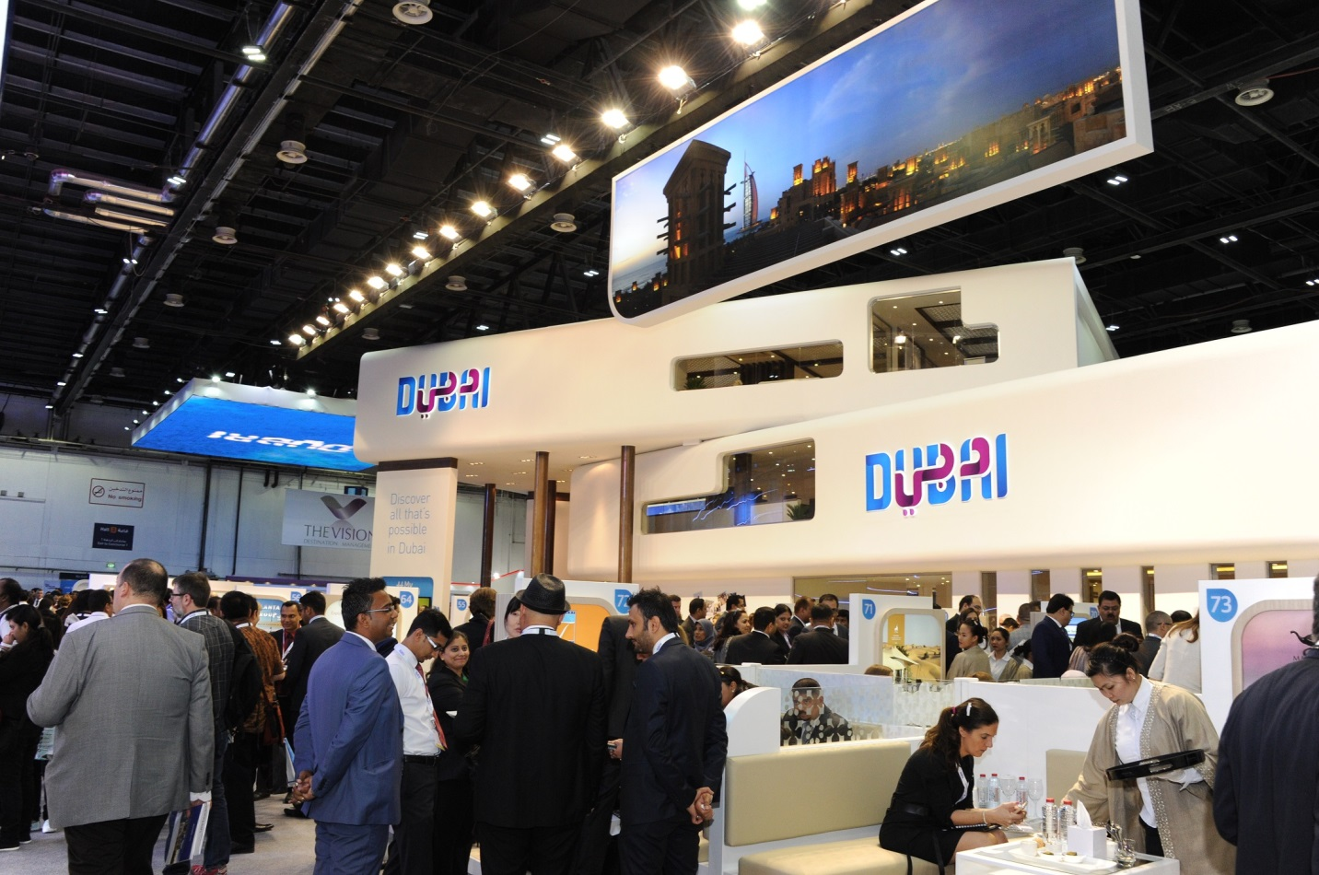

Dubai, UAE; 20 April 2017: Dubai’s Department of Tourism and Commerce Marketing (Dubai Tourism), together with over 90 representatives from private and public sector entities, will be taking part at this year’s Arabian Travel Market (ATM) being held in Dubai from 24-27 April, 2017 at the Dubai International Convention and Exhibitions Centre. As one of the exhibition’s official partners, Dubai Tourism, on stand ME 3110, will be showcasing the emirate’s diverse and ever-evolving tourism offerings to the local and international travel trade community. Dubai Tourism will also leverage its presence at the event to reveal new initiatives, programmes and industry reports.

Issam Kazim, CEO, Dubai Corporation for Tourism and Commerce Marketing (DCTCM) said: “ATM serves as a platform to highlight Dubai’s appeal as a global tourist destination as the emirate continues to drive tourism growth in line with our Tourism Vision for 2020. It’s also a key event in Dubai Tourism’s annual calendar as it is a focal point for the travel trade community to connect and network. We are looking forward to showcasing Dubai’s dynamic tourism offerings, including a whole host of innovations launched over the past year, such as Dubai Parks & Resorts, Dubai Opera, Etihad Museum and the Dubai Water Canal.”

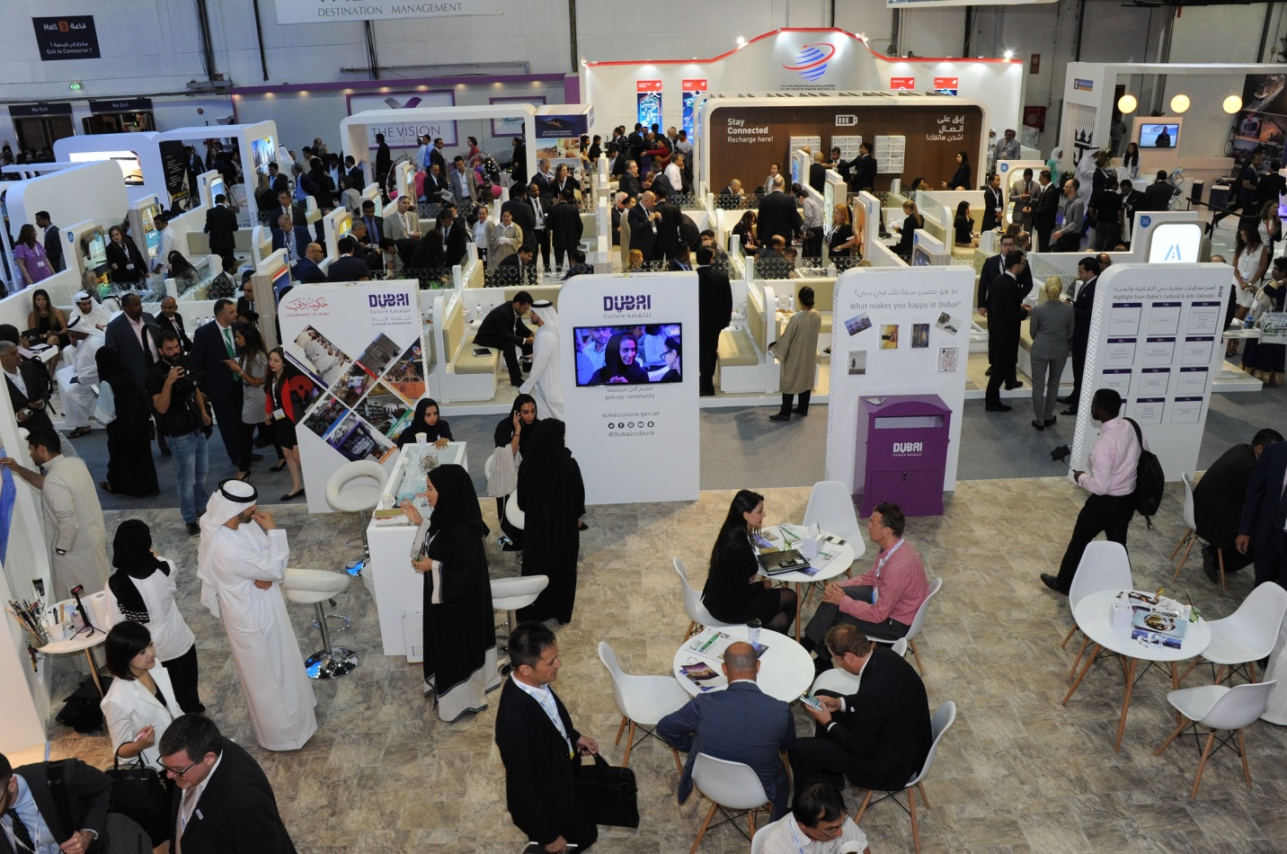

The Dubai stand has been designed to highlight the breadth of the emirate’s destination offering through numerous content-rich concepts and interactive activations. Covering an area of 1,200 square metres and rising three storeys high, the enhanced Dubai stand will offer a unique, immersive visitor experience that brings together the various aspects that make Dubai an exciting tourist destination. In addition, Dubai Tourism has partnered with TAG Heuer, who will be on the stand during this year’s ATM. The iconic watch brand will exclusively be unveiling their newest line during the show.

Visitors can enjoy speciality drinks from the on-stand Gahwa Café, which this year will be run by home grown Cocoville, as well as getting a glimpse into how Virtual Reality (VR) technology is transforming the travel and tourism industry as the demand from travellers looking for new experiences, continues to grow. The stand will feature MyJetSki, a locally owned company which offers water tours of the city on jet skis.

The Dubai College of Tourism will be demonstrating a new interactive training tool, designed to help international agents and customer-facing tourism representatives in Dubai to promote the emirate as an ideal holiday destination. These innovative tools use gamification to help educate users about the city and feature engaging interfaces that include information on tourism attractions in easily-digestible formats.

ATM will also provide the international travel trade market with the opportunity to discover the various sustainability initiatives that are being put in place to ensure the emirate’s tourism industry contributes to the clean energy and sustainable development targets that have been put in place. Dubai Sustainable Tourism will be highlighting projects, training tools and new standards currently being implemented across the industry that support Dubai’s goal of becoming one of the world’s leading sustainable tourism destinations.

Joining forces with Dubai Tourism at ATM will be its agency, the Dubai Festivals and Retail Establishment (DFRE), who will showcase an exciting calendar of events planned for the second half of 2017 and various other entities – the Dubai Culture and Arts Authority (Dubai Culture) who will highlight key initiatives being led in the cultural tourism sector and will also offer complimentary portraits by a live artist; and EXPO 2020, whose presence will underscore the importance of the global event in helping boost Dubai’s knowledge economy and position the emirate as a hub for business.

The Dubai stand will also see participation from key government bodies such as Dubai Police, whose presence will underline the emirate’s strong safety and security credentials; the Department of Naturalisation and Residency Dubai (DNRD), who will use ATM to highlight advances in visa policies and processes that will make it easier for visitors from all nationalities to enter Dubai; and Dubai Health Authority (DHA) who will focus on the evolving medical tourism proposition. These will be joined by more than 90 co-participants, made up of hotels and hotel apartment establishments, tour operators and destination management companies, event and conference space providers.

The Dubai team can be found on stand ME3110 at the Dubai World Trade Centre from 24-27 April 2017.

- Ends -

About Dubai’s Department of Tourism and Commerce Marketing (Dubai Tourism)
With the ultimate vision of positioning Dubai as the world’s leading tourism destination and commercial hub, Dubai Tourism’s mission is to increase the awareness of Dubai among global audiences and to attract tourists and inward investment into the emirate.

Dubai Tourism is the principal authority for the planning, supervision, development and marketing of Dubai’s tourism sector. It markets and promotes the Emirate’s commerce sector, and is responsible for the licensing and classification of all tourism services, including hotels, tour operators and travel agents. Brands and departments within the Dubai Tourism portfolio include Dubai Business Events, Dubai Calendar, and Dubai Festivals and Retail Establishment.

For further information please contact:
Dubai Tourism
mediarelations@dubaitourism.ae
[+971] 600 55 5559
[+971] 4 201 7631

