Press Release

Dubai Tourism unveils innovative training tool for travel agents at ATM 2017

‘Dubai Expert’ announced a first-of-its-kind destination travel trade training programme that will be rolled out to travel agents from around the world

Dubai, UAE: 26 April, 2017: Dubai’s Department of Tourism and Commerce Marketing (Dubai Tourism), has announced the launch of “Dubai Expert”, an innovative online educational game that has been created exclusively for travel agents. The announcement was made to travel professionals attending this year’s Arabian Travel Market in Dubai, which runs until 27 April.

Created in collaboration with the Dubai College of Tourism (DCT) and KTM Advance, a specialist in e-learning, the learning tool is a marked departure from traditional training programmes. It features an engaging interface that includes information on Dubai’s tourism attractions in an easily-digestible format that will enable agents to promote the Emirate as the ideal holiday destination to their customers from around the world.

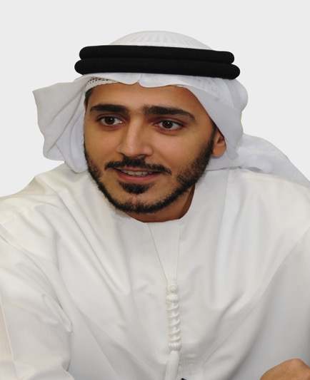
Speaking at ATM 2017, Issam Kazim, CEO of Dubai Corporation for Tourism and Commerce Marketing (DCTCM), said: “Our partnerships with travel agents are critical to us as we look to expand our influence and reach across industry channels and stakeholders that influence tourists looking to visit Dubai. This also means that we need to keep developing new tools that allow us and our partners to highlight what makes Dubai a ‘must-visit’ destination. With the ‘Dubai Expert’ platform, we have used technology innovation to transcend typical training programmes and create an experience that enhances their knowledge of Dubai, so they can build customised itineraries that will attract more visitors. ‘Dubai Expert’ has been created to facilitate this process and is part of our continued endeavour to achieve our strategic goal of welcoming 20 million visitors by 2020.”

‘Dubai Expert’ operates as a turn-based card game, where participants will need to select the best cards – each with an attraction in the city – from an automatically generated deck, to create an ideal itinerary for a traveller. Various traveller profiles make up the 30 ‘missions’ of the game, with the best combination of activities earning higher scores. The platform also includes 25 videos from experts that serve as a guide of what to do in Dubai – including family entertainment, gastronomy, shopping, theme parks, culture and heritage amongst others.

Participants can become a ‘Dubai Expert’ by completing 20 successful missions and watching all 25 expert videos, with a higher ‘Dubai Expert’ level achieved by completing all 30 missions and answering all pop-up questions about the city. In order to maintain this status, players are required to return to the game every year and complete updated missions and watch newer expert videos.

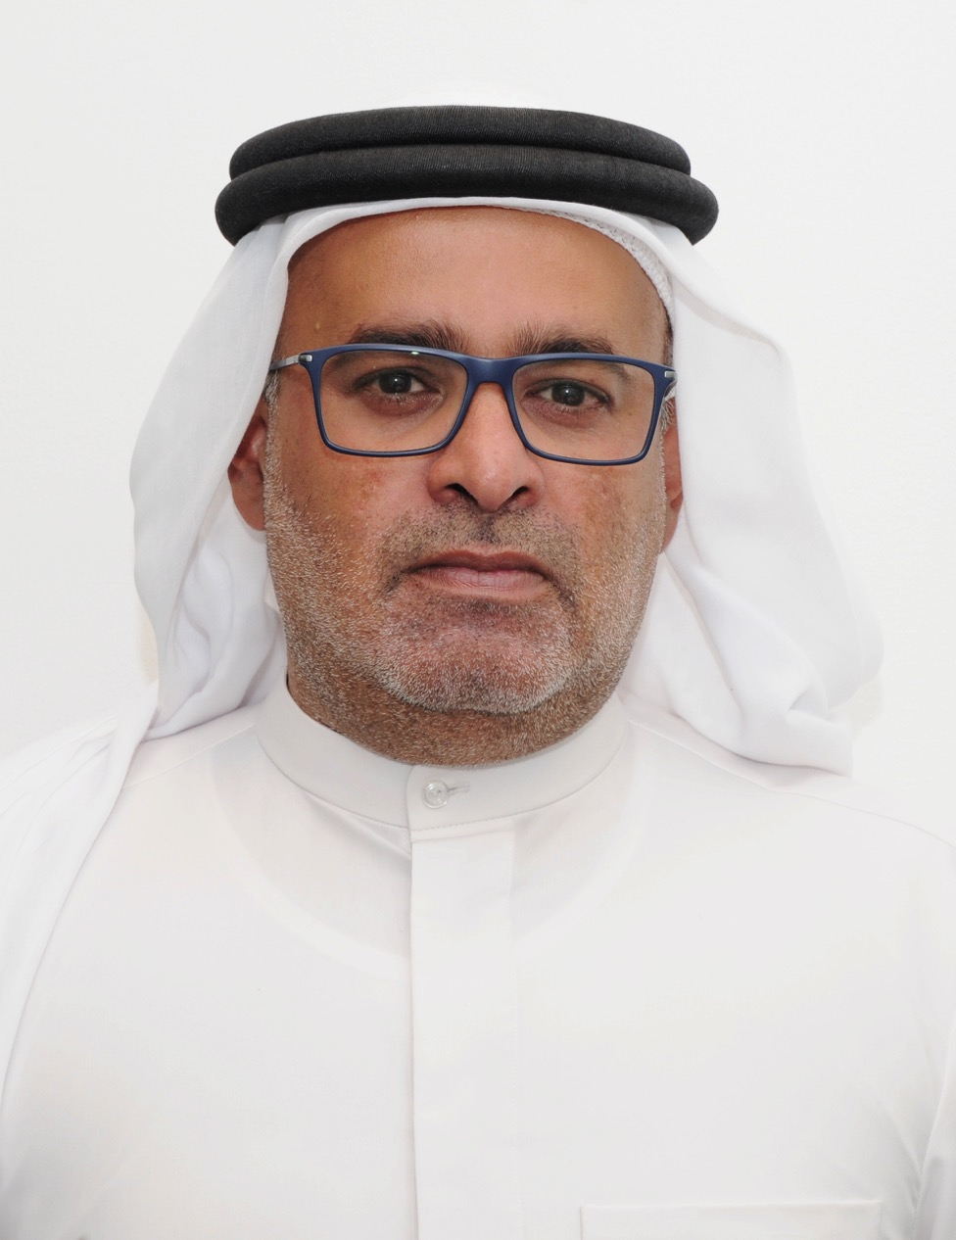
Essa Bin Hadher, General Manager, Dubai College of Tourism, added: “While we strive to engage more individuals with the city’s booming tourism industry, we also understand the importance of reaching out to global travel agents. From flights and accommodation to dining and experiences across the city, travel agents streamline the entire booking process for tourists – and in turn help increase the number of visitors to Dubai every year. We are excited to have assisted Dubai Tourism with the creation of ‘Dubai Expert’, to not only provide agents with a clearer glimpse of the city, but also to help them understand different audiences and create itineraries that best suit them.”

Along with building their knowledge of Dubai, travel agents can also enjoy benefits such as invites to various events in the city, as well as a ‘Dubai Expert Certificate’ and the use of the ‘Dubai Expert’ logo. The tool will first be launched in English across multiple key markets and will then be translated into various languages including French, Mandarin, Russian, German, Italian, Bahasa, Korean, Japanese, Polish, Czech, and Spanish. There are also plans to create a global league table of Dubai Expert users, allowing agents from all over the world to compete against each other to achieve the highest score.

- Ends -

About Dubai’s Department of Tourism and Commerce Marketing (Dubai Tourism)
With the ultimate vision of positioning Dubai as the world’s leading tourism destination and commercial hub, Dubai Tourism’s mission is to increase the awareness of Dubai among global audiences and to attract tourists and inward investment into the emirate.

Dubai Tourism is the principal authority for the planning, supervision, development and marketing of Dubai’s tourism sector. It markets and promotes the Emirate’s commerce sector, and is responsible for the licensing and classification of all tourism services, including hotels, tour operators and travel agents. Brands and departments within the Dubai Tourism portfolio include Dubai Business Events, Dubai Calendar, and Dubai Festivals and Retail Establishment.

About Dubai College of Tourism (DCT)
DCT seeks to deliver the first-of-its-kind multi-disciplinary educational platform in the region. The College will provide foundation, certificate and diploma courses in tourism, hospitality, retail, events and culinary arts through the TVET accreditation framework. The college is also responsible for delivering fundamental programmes specifically designed for those working within the tourism industry, such as ‘Dubai Way’ (for tourist-facing staff in Dubai) and ‘Dubai Expert’ (an interactive online training tool for international travel agents). For more information on DCT email dct@dubaitourism.ae.

For further information, please contact:
Dubai Tourism
mediarelations@dubaitourism.ae
[+971] 600 55 5559
[+971] 4 201 7631

