Dubai Tourism hosts OVER 200 members of the hotel industry at Dubai Parks AND RESORTS
Showcasing the city’s latest developments with the aim of consistently improving the level of knowledge and service Dubai’s hotels can offer to visitors

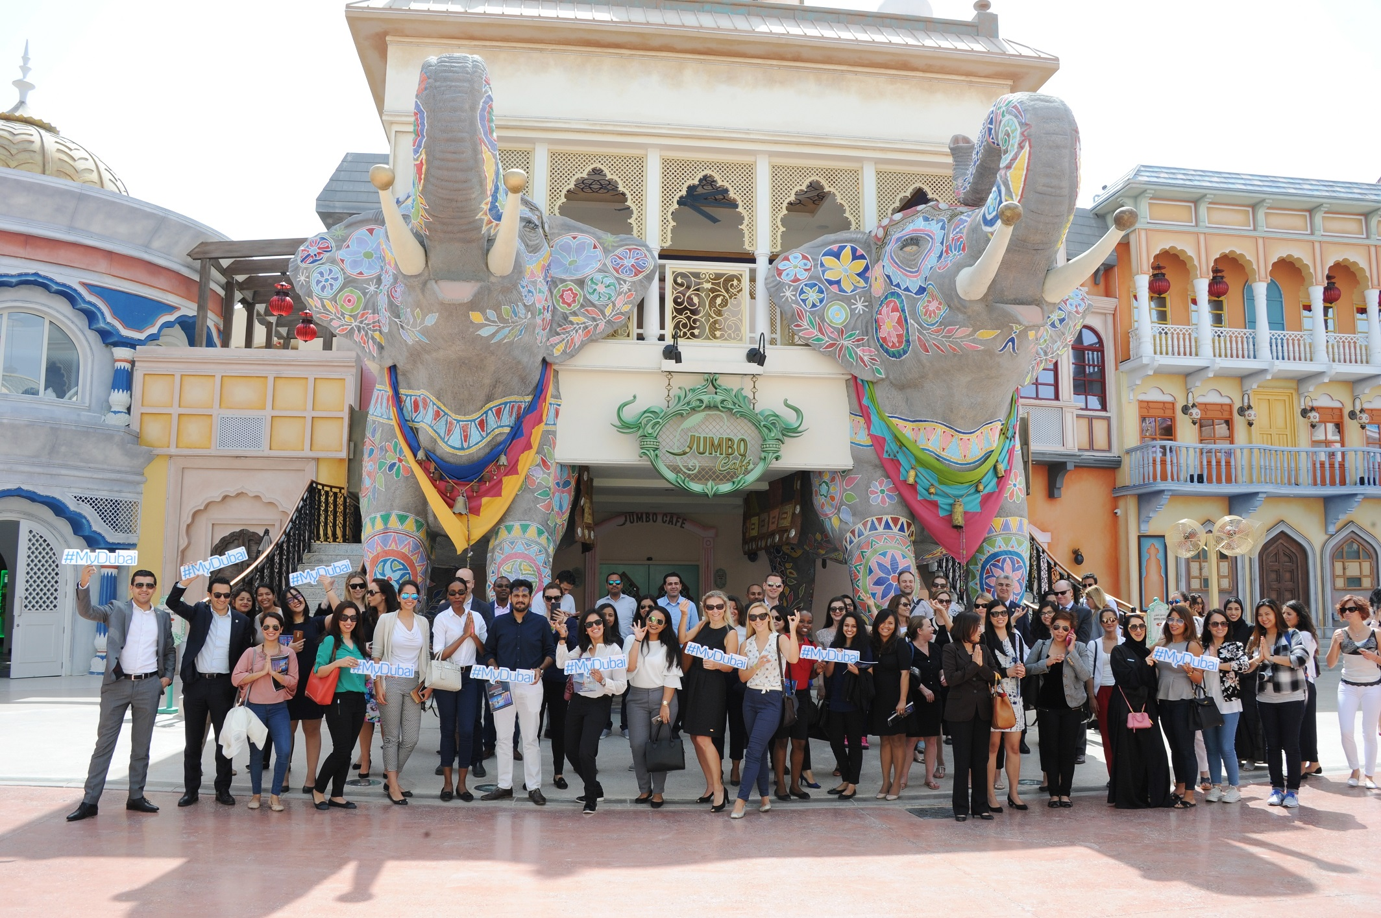
Dubai, UAE: 20 April, 2017: Dubai’s Department of Tourism and Commerce Marketing (Dubai Tourism) held an event today for the hotel industry in partnership with Meraas and Dubai Parks and Resorts. Hosted at Bollywood Parks, the event gathered concierges and members of the hotel community from across the Emirate to share updates and information on the latest hospitality offerings and experiences across Dubai.

Over 200 attendees were taken on a tour of the parks and Riverland, as well as given updates on various projects in the pipeline. The objective of the forum was to ensure the best level of local knowledge and service be consistently offered to visitors by Dubai’s hotel community.

Dubai Tourism’s efforts, alongside those of its partners, are testament to the ongoing commitment to deliver exceptional visitor experience and promote Dubai as one of the world’s leading destinations for tourists and business visitors alike.

Issam Kazim, Chief Executive Officer of Dubai Corporation for Tourism and Commerce Marketing (DCTCM) said: “Our partners in the emirate are of utmost importance to our efforts to promote Dubai as a destination as we head towards 2020, and their support is truly invaluable. We are very happy to be able to host members of Dubai’s hotel community today who represent the city first hand and we will continue to invest in our relationship with them.”

- ends -
About Dubai’s Department of Tourism and Commerce Marketing (Dubai Tourism)
With the ultimate vision of positioning Dubai as the world’s leading tourism destination and commercial hub, Dubai Tourism’s mission is to increase the awareness of Dubai among global audiences and to attract tourists and inward investment into the emirate.

Dubai Tourism is the principal authority for the planning, supervision, development and marketing of Dubai’s tourism sector. It markets and promotes the Emirate’s commerce sector, and is responsible for the licensing and classification of all tourism services, including hotels, tour operators and travel agents. Brands and departments within the Dubai Tourism portfolio include Dubai Business Events, Dubai Calendar, and Dubai Festivals and Retail Establishment.

